**Smart Parking System**

**21-BSSE-P11**



**SESSION 2017-2021**

**BACHELOR OF SCIENCE**

**IN**

**SOFTWARE ENGINEERING**

**SUBMITTED BY**

**Rifah Zahid 17-NTU-1058**

**Qudsia Zia 17-NTU-1057**

**Sanwan Aslam 17-NTU-1062**

## SUPERVISED BY

## Mr. Nasir Mehmood

## CO-SUPERVISED BY

## Mr. Muhammad Shahid

## DEPARTMENT OF COMPUTER SCIENCE

**NATIONAL TEXTILE UNIVERSITY, P.O-37610 FAISALABAD**

**DECLARATION**

We hereby declare that this project report entitled “Smart Parking System” is written by us and is our own effort and that no part has been copied or taken without a mentioning reference of source

Submitted by Signature Date

Rifah Zahid _______________________________ ______________________

Qudsia Zia _______________________________ ______________________

Sanwan Aslam _______________________________ ______________________

This project document is submitted to the Department of Computer Science at National Textile University in partial fulfilment of the requirements for the degree of Bachelor of Science in Computer Science. The Project is equivalent to 32 weeks of full-time studies. We have read the report and confirm that this report meets the minimum requirements for the degree of Bachelor of Science in Software Engineering (BSSE).

**Contact Information:**

Author(s):

Rifah Zahid ______________________________ _____________________ 17-NTU-1058 **Signature Date**

Qudsia Zia _________________________________ _____________________

17-NTU-1057 **Signature Date**

Sanwan Aslam _________________________________ _____________________

17-NTU-1062 **Signature Date**

Department of Computer Science Web: [www.ntu.edu.pk](http://www.ntu.edu.pk)

National Textile University Phone: +92 4192 30 081

P.O ± 37610 Faisalabad Fax: +92 41 92 30 098

Faisalabad

**CERTIFICATION**

This is to certify that this project titled “Smart Parking System” was found to satisfy the requirement for the award of “Bachelor of Sciences in Software Engineering” degree by the Department of Computer Science, National Textile University.

_________________________ _____________________

**Supervisor: Date**

Mr. Nasir Mehmood

_________________________ _____________________

**External Examiner Date**

_________________________ _____________________

**Internal Examiner (FYP-Member) Date**

Name:

_________________________ _____________________

**FYP-Convener Date**

Dr. Rehan Ashraf

_________________________ _____________________

**Head of Department Date**

Dr. Muhammad Asif Habib

**ACKNOWLEDGEMENT**

This project is developed by maximum amount of hard work and our full dedication. In this System, many people have paid huge amount of contribution through which we will be able to achieve our goal. We are very thankful for their precious time they rewarded us without their guidance and their kind advices we are nothing.

We thank thousand times to ALLAH for the knowledge and perseverance that has blessed upon us during this whole effort and throughout our life, “We are nothing without this strength that ALLAH showered upon us”. Our class fellows and our seniors who played major role to support us, encourage us and to strengthen us.

We pay our greatest gratitude to the most respected Faculty Members of our Department who gave us their precious time from their busy schedules, and they are so kind and friendly that we even cannot describe this in words. We would like to thank our **Supervisor Mr. Nasir Mehmood** and **Co-Supervisor Mr. Muhammad Shahid** for guiding us throughout this whole project and progress.

They guided us in every module of project and consulted them what new advancement will be. We pay nothing except our respect for their guidelines and continuous support and effort.

We thank every person from the core of heart who guided us directly and indirectly.

I would like to thank our **Convener Dr. Rehan Ashraf** for motivating us throughout this project, without him we will not be that serious.

Respected Faculty members have helped us a lot and guided us according to their experience. They inspired us a lot So that we are here at this stage to present our work.

Finally, we are very thankful to our parents who provided us this platform their guidance, motivation, support (financial and emotional) throughout our journey of four years. The patience, support and understanding shown by our parents, brother and sister is most appreciated.

Table of Contents

**Chapter 1** 1

**Introduction** 1

1.1 Introduction 2

1.2 Purpose 3

1.3 Project Scope 3

1.4 Area of Studies 3

1.5 Gathering Requirements 3

1.6 Project Planning 4

1.7 Risk Management 4

1.8 Project Overview 5

**Chapter 2** 6

**Literature Review** 6

2.1 Related Work 7

2.1.1 Selecting ROIS 7

2.1.2 Detecting ROI using Canny function 8

2.1.3 Identifying empty/filled parking spaces 9

2.2 Areas of Studies 10

2.3 Reasons of Development 10

2.4 Proposed Methodology 11

2.4.1 Noise Reduction 11

2.4.2 Finding Intensity Gradient of the Image 11

2.4.3 Non-maximum Suppression 12

2.4.4 Hysteresis Thresholding 12

2.5 Experiments 13

2.6 Parking System 15

**Chapter 3** 17

**Problem Definition** 17

3.1 Problem Definition 18

3.2 Existing Methodologies 18

3.3 Adopted Methodologies 19

3.3.1 Incremental Prototype 19

3.4 Reason for Adopting Methodologies 20

**Chapter 4** 21

**System Requirement** 21

4.1 Functional Requirements 22

4.2 Requirement Table 23

4.3 Non-Functional Requirements 23

4.4 Functional Requirements Context 25

4.4.1 Context 25

4.4.2 Values 26

4.4.3 Analysis 27

4.4.4 Generate Report 27

4.5 Class Diagram 28

4.6 Use Case Diagram 28

4.6.1 Admin 28

4.6.2 User 30

4.6.3 Complete System 32

4.7 Data Flow Diagram 33

**Chapter 5** 34

**Architecture Design** 34

5.1 Architecture 35

5.2 System Architecture 35

5.3 Sequence Diagram 36

5.3.1 User Sign-In Sequence Diagram 36

5.3.2 Forgot Password by User Sequence Diagram 37

5.3.3 Register User Sequence Diagram 38

5.3.4 Guest Login Sequence Diagram 39

5.3.5 View Cities by User Sequence Diagram 40

5.3.6 View Mall by User Sequence Diagram 41

5.3.7 View Parking Slots by User Sequence Diagram 42

5.3.8 Book Parking by User Sequence Diagram 43

5.3.9 Generate Analytics Report by Admin Sequence Diagram 44

5.4 Activity Diagram 45

5.4.1 Register_User log-In Activity Diagram 45

5.4.2 Reset Password by Register_User Activity Diagram 45

5.4.3 View Parking Slots by Guest_User Activity Diagram 47

5.4.4 View Parking Slots by Register_User Activity Diagram 48

5.4.4 Book Parking Slots by Register_User Activity Diagram 49

5.4.5 Select Parking Slots by Admin Activity Diagram 50

5.4.5 Delete User by Admin Activity Diagram 50

5.4.6 Generate Analysis Report by Admin Activity Diagram 51

5.5 Data Flow Diagram 53

5.5.1 0-Level Data Flow Diagram 53

5.5.2 1-Level Data Flow Diagram 55

5.5.3 2-3-Level Data Flow Diagram 56

**Chapter 6** 57

**Testing** 57

6.1 Test Cases 58

6.2 Black Box Testing 58

6.2.1 Sign-In Test Case 58

6.2.2 Sign-Up Test Case 60

6.2.3 Forgot Password Test Case 62

6.2.4 Book a Spot Test Case 64

**Chapter 7** 67

**User Manual** 67

7.1 Interface 68

7.1.1 Sign-In Interface 68

7.1.2 Sign-Up Interface 69

7.1.3 Forgot Password Interface 70

7.1.4 Home for Registered User Interface 71

7.1.5 Home for Guest User Interface 72

7.1.6 Select City Interface 73

7.1.7 Select Mall Interface 74

7.1.8 Parking Slots Interface 75

7.1.9 Contact Developer Interface 76

7.1.10 Reserve Your Parking Spot Interface 77

8 Summary 78

9 Reference 79

**List of Figures**

Figure 2.1: selectRois() function operation......... ………………..……………………8

Figure 2.2. Some sample of data like which will be our live video streams………….9

Figure 2.3: Canny function operation……………………....……..………………….9

Figure 2.4. Detection and identification of available and unavailable parking ……...10

Figure 2.5. Detection and identification of available and unavailable parking ……..10

Figure 2.6. Canny function logic (1)………………………………..............………..12

Figure 2.7. Canny function logic (2)...........………………………………………….13

Figure 2.8. Applying canny algorithm on Video Source Data …................................13

Figure 2.9. ROIS Selected from Video-Source……………………………………....14

Figure 2.10. ROIS Detected as Available and Unavailable from Video-Source........14

Figure 2.11. Parking Slots View in android application…………………………….15

Figure 3.1. Incremental Prototype Model…………………………………………..19

Figure 4.1. Smart Parking Process Flow…………………………………………….25

Figure 4.2 – Class Diagram of Smart Parking System……………………………..28

Figure 4.3 – Admin………………………………………………………………….29

Figure 4.4 – Register User --->View Booked slots….….…………………………..30

Figure 4.5 – Register User ---> Login………………………………………………31

Figure 4.6 - Registered User………………………………………………………..31

Figure 4.7 – Complete System Use Case Diagram…………………………………32

Figure 4.8 – Data Flow Diagram……………………………………………………33

Figure 5.1. System Architecture……………………………………………………35

Figure 5.2. User Sign-In Sequence Diagram………………………………………36

Figure 5.3. Forgot Password by User Sequence Diagram………………………….37

Figure 5.4. Register User Sequence Diagram………………………………………..38

Figure 5.5. Guest Login Sequence Diagram…………………………………………39

Fig. 5.6. View Cities by User Sequence Diagram……………………………………40

Fig. 5.7. View Mall by User Sequence Diagram……………………………………..41

Fig. 5.8. View Parking Slots by User Sequence Diagram……………………………42

Figure. 5.9. Book Parking by User Sequence Diagram…...…………………………43

Figure. 5.10. Generate Analytics Report by Admin Sequence Diagram…………….44

Figure. 5.11 Register_User Sign-In Activity Diagram………………………………45

Figure. 5.12 Register_User Forget Password Activity Diagram……………………46

Figure. 5.13 Guest_User View Parking Slots Activity Diagram……………………47

Figure. 5.14 Register_User View Parking Slots Activity Diagram…………………48

Figure. 5.15 Register_User Book Parking Slots Activity Diagram…………………49

Figure. 5.16 Admin Select Parking Slots Activity Diagram……………….……….50

Figure 5.17 Admin Delete User Activity Diagram………………………….………51

Figure. 5.18 Admin Generate Date Vise Report Activity Diagram…………………52

Figure. 5.19 Admin Generate Week Vise Report Activity Diagram………..………52

Figure. 5.20 Admin Generate Hour Vise Report Activity Diagram……………...…53

Figure. 5.21. 0-Level Data Flow Diagram………………………………………..…54

Figure. 5.22. 1-Level Data Flow Diagram…………………………………………..55

Figure. 5.23. 2-3-Level Data Flow Diagram…………………………………..……56

Figure. 6.1. Sign-In Test Case………………………………………………….…...58

Figure. 6.2. Sign-Up Test Case……………………………………………………..60

Figure. 6.3. Forgot Password Test Case…………………………………………….62

Figure. 6.4. Book a Spot Test Case…………………………………………………64

Figure. 7.1. Sign-In Interface………………………………………………………...68

Figure. 7.2. Sign-Up Interface……….……………………………………………….69

Figure. 7.3. Forgot Password Interface………………………………………………70

Figure. 7.4. Home for Registered User Interface……………………………………71

Figure. 7.5. Home for Guest User Interface…………………………………………72

Figure. 7.6. Select City Interface……………………………………………………73

Figure 7.7. Select Mall Interface……………………………………………………74

Figure. 7.8. Parking Slots Interface………………………………………………....75

Figure. 7.9. Contact Developer Interface……………………………………….…..76

Figure. 7.10. Reserve Your Parking Spot Interface………………………………...77

**List of Tables**

Table 1-1: Project Planning……………………..………………...……….….....4

Table 2.1: Parking Records Shows……………………………………………. 16

Table. 4.1. Requirement Table………………………………………………….23

Table. 6.1. Sign-In Test Case Table…………………………………….………59

Table. 6.2. Sign-Up Test Case………………………………………………….61

Table. 6.3. Forgot Password Test Case………………………………………...63

Table. 6.4. Book a Spot Test Case……………………………………………..65

**ABSTRACT**

In this era of efficiency and performance machines and systems tends to be better and faster. Everything is being automated and self-aware for making lives easy and less tensed. The issue of parking-lots is immense in most of our areas, especially in big malls and big organizations where they have a very large area that is assigned for parking. Therefore, we intended to aid the parking-lots of the big malls and big organization by bringing a mobile application that identifies the free parking-lot of a specific mall or organization where you want to go before going to the mall or the organization, by using the networked system. This app can also adjust the parking fee according to the duration of parking. The aim of this application is to provide an ease for the customer and for the management that the customer does not have to move around the parking-lot to find the space when there is no space available. Thus, this saves their time.

# **Chapter 1**

# **Introduction**

## 1.1 Introduction

“Smart Parking System” is an automatic system for identifying the free parking spaces in a parking area. It is a hectic task to find parking in a busy parking area, especially when there are less, or no spaces left for parking [1]. In addition, going to a mall or a parking area with no empty parking spaces wastes so much time that can be utilized in a better way [2]. Our system is a solution that specifically handles the finding parking problem, stores the parking information in the database and display the real-time information in the android application to the user. So rather than going and finding parking manually, you can use the app to see if there’s parking available and you should go or not [3].

In this project, selectROIS function of OpenCV and the Canny Edge Detection operation of OpenCV is being used to first select our parking slots and then apply the Canny function to detect whether the parking spot is available for others car to be parked or it is unavailable, as some car is already parked in the spot. The Canny function detects the edges in the Roi (one parking spot individually) and then according to a threshold that we have set, it determines whether the pixels in the Roi were enough to label it as unavailable or the pixels were less than the set threshold to label it as available parking spot.

Also, the app provides the user the functionality to book a parking spot in advance if the user wants to go to the mall. However, this has a limitation that if a regular driver, who does not use the app and has not booked the slot, parks in a booked spot, then the user who has booked the spot cannot get a new booking and thus his booking is wasted.

The challenges our project is addressing are:

* Be able to accurately sense vehicle occupancy in real-time.
* Provide guidance for users about available parking.
* Simplify the parking experience and add value for parking stakeholders, such as drivers.
* Enable intelligent decisions to be made using data, including real–time status applications, and historical analytic reports.
* Be able to provide the user with all the necessary information about the status of any changes in the parking area that might happen in real time.[4]

## 1.2 Purpose

The purpose of development and implementation of the “Smart Parking System” is to make it easy for the visitors and the parking area management to utilize and manage the parking areas effectively and efficiently. Because minimum 5-7 minutes of the customer are spent in finding the parking spaces each time when he goes to a busy parking area. It is a massive solution to address many problems with traditional parking systems.

## 1.3 Project Scope

Our proposed system can be used by any kind of firm, organization, mall, parking plaza, universities, or places wherever there are large parking areas, and they are very busy, or we want to know and record the entering and exit time of cars. Our system can be used wherever parking is an issue and parking records need to be stored, and they use a conventional method like registers, files etc. to record parking in and outs.

## 1.4 Area of Studies

In our 4 years of study in this degree, different courses like Software Engineering, Artificial Intelligence, Database Designing, Software Architecture and Design, Data Science have been studied and will be helpful in development of this Project. Artificial Intelligence and Database Design and Analysis play an important role during the development and implementation of this project.

## 1.5 Gathering Requirements

The most important part of every project is that how you gather requirements and how accurate you can work and understand that requirements. If the requirements that you gathered are correct then there will be less change in project through which the project will be error free and meets the requirements of user but if the project requirements are not accurate so for any change in project, we must start it from the initial stage which will be costly and time consuming. To control the risk, we must collect the requirements with a complete homework and should be accurate. We might consult with the clients; our system expected users or the organization that currently have implemented the system like our proposed one. However, if the error or risk has occurred you will be able to change that module and part in such a way as with little changes.

After the requirement gathering verify them in the best way and understand, what the client wants “Listen to him carefully”.

## 1.6 Project Planning

Table. 1.1. Project Planning

|  |  |  |  |  |  |  |  |  |  |
| --- | --- | --- | --- | --- | --- | --- | --- | --- | --- |
| **Task** | **Dec** | **Jan** | **Feb** | **Mar** | **April** | **May** | **June** | **July** | **Aug** |
| Topic Selection |  |  |  |  |  |  |  |  |  |
| Finalize  Topic |  |  |  |  |  |  |  |  |  |
| Gather Requirements |  |  |  |  |  |  |  |  |  |
| Analyze Requirements |  |  |  |  |  |  |  |  |  |
| SRS Document |  |  |  |  |  |  |  |  |  |
| Write Document |  |  |  |  |  |  |  |  |  |
| Modify |  |  |  |  |  |  |  |  |  |
| Submit |  |  |  |  |  |  |  |  |  |

## 1.7 Risk Management

Organizations like offices, malls, and parking plazas must have a reliable system that is well structured and easy to maintain. There can be problem that the cameras might not be able to detect all the parking spaces at the area and may miss out a few who are not in frame. Therefore, we must maintain a real-time database so that there is no integrity and inconsistency issues with the database records and the real parking situation.

The risks that we face in the development phase are as follows:

* Integrating multiple cameras in the system
* Difficulty of detecting and identifying the parking slot if the camera quality is low.
* Might be system cost issues
* System performance can be low as we do not have high performance systems

## 1.8 Project Overview

This project is designed to tackle with the manual parking system, which is currently being used in our malls, offices, and parking plazas. A smart parking system will be helpful to the users or customers that they do not have to waste the time on finding the parking manually and that almost 5-7 minutes of their valuable time can be saved.

In addition, there is no centralized database to keep the record of cars parked. Therefore, with this system we can be able to store the parking records and credentials on a centralized server. Also led a helping hand to the management of the parking. Moreover, by using this system there should be integrity and consistency in the parking records.

# **Chapter 2**

# **Literature Review**

## 2.1 Related Work

Currently there are very few parking areas in Pakistan (less than 1 %) using an automated system for parking, that identifies free parking lots and makes this information accessible on a mobile app. When specifically talking about Faisalabad, there is no such system installed in any parking area. Many of them manually track the cars parked in the parking area and where they are parked, a few of which record the cars’ entry exit in the computer systems. It means right now there is a need of convergence of old technologies.

We are going to design a system, which will be useful to shopping malls, parking plazas, offices and many other locations where finding free parking is a hassle.

* + It is going to provide these services to the parking areas:
  + Automatic counting and location identification of free parking lots
  + Save a lot of time
  + Manage a centralized database
  + Accuracy, and consistency in the parking management

There are many theses and reports available on the internet/ in libraries that can be useful for our project. Like;[3]

### 2.1.1 Selecting ROIS

selectROIS() Allows users to select multiple ROIs on the given image. The function creates a window and allows users to select multiple ROIs using the mouse. Controls: use space or enter to finish current selection and start a new one, use esc to terminate multiple ROI selection process. [5]

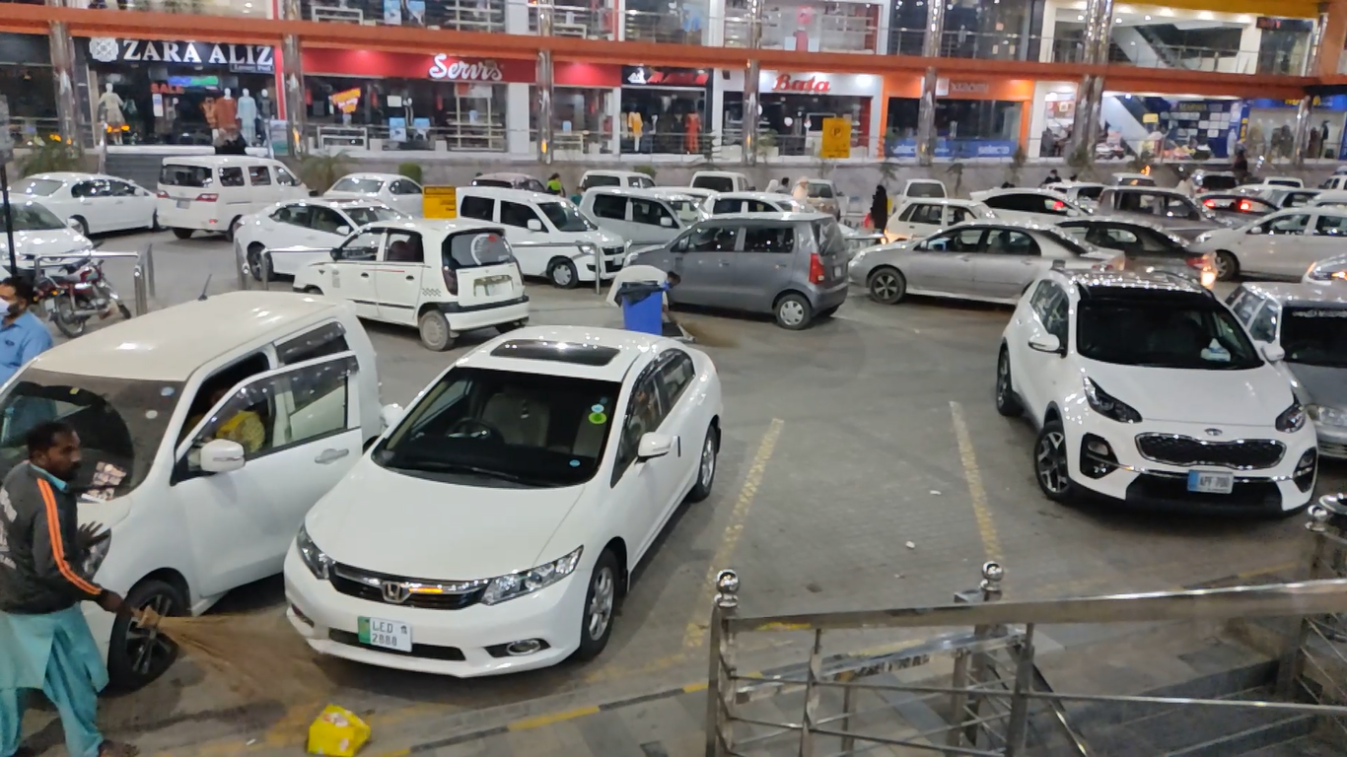

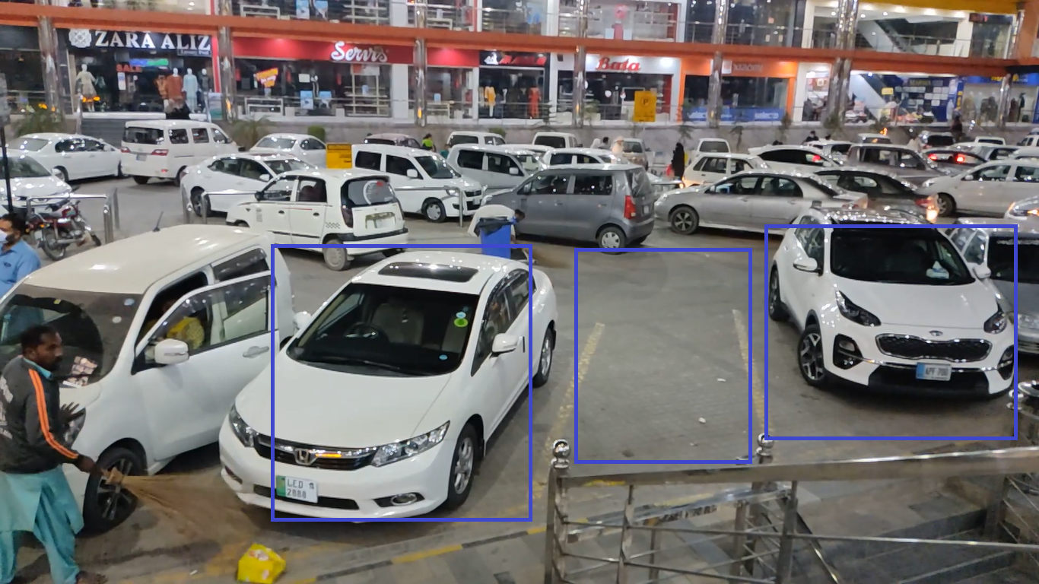

Figure 2.1: selectRois() function operation. [5]

### 2.1.2 Detecting ROI using Canny function

To detect parking and decide whether its free or filled, we must process the selected ROIS. Canny edge detection is then applied to the incoming videos from the camera source and each ROI processed individually. Each ROI is checked for the number of white pixels, corresponding to the edges in the region. If a car is parked in the ROI (parking spot), the number of white pixels is high and thus we detect the parking spot as filled/unavailable. But, if the number of white pixels is low than the set threshold, we identify the parking spot as available/free. [6]

Our first improvement approach when detecting parking lots is to apply the Canny edge detection algorithm on our identified ROIS, with adjustable thresholds. We can adjust the values of min and max pixels to select the one that gives the best detection accuracy result, which vary in different environments and lighting. For example,

In the second approach, we compared effects of this adjusting thresholds on accuracy performance of available/unavailable spot detection. We selected the thresholds that gives the best result.

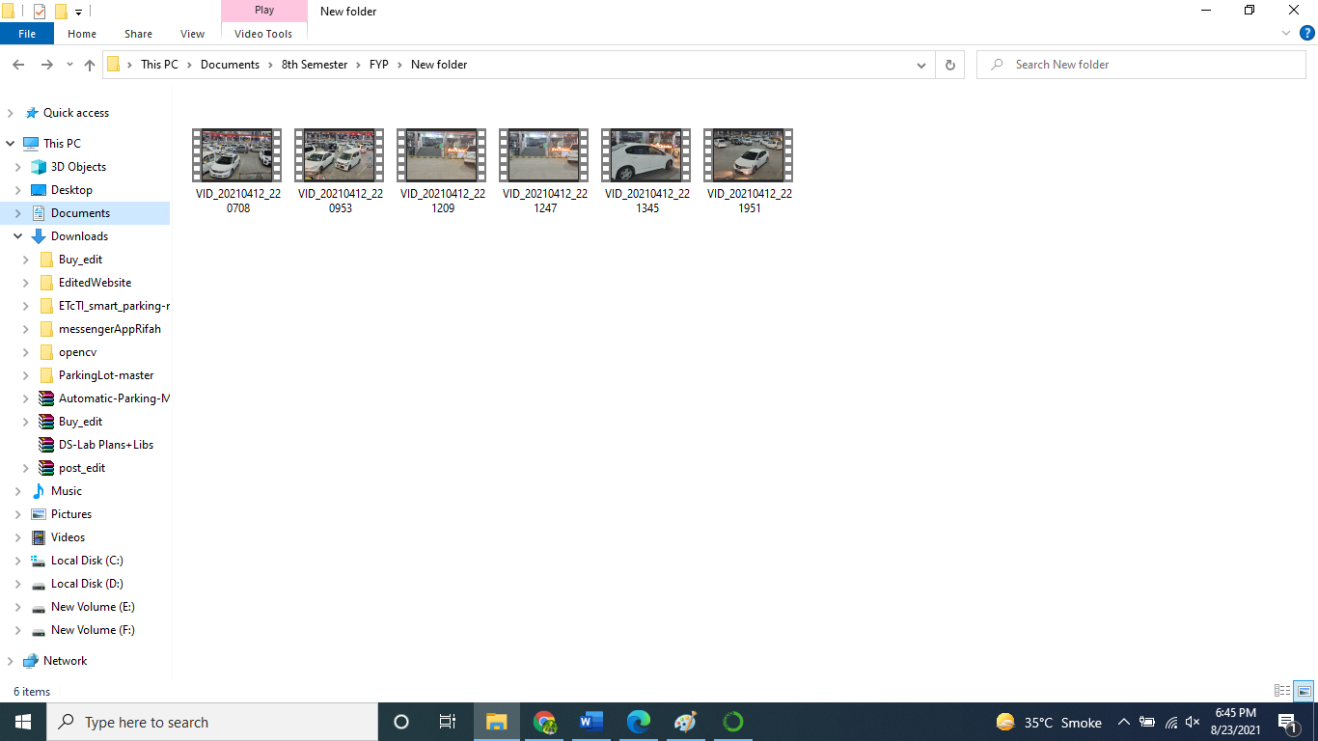

Figure 2.2. Some sample of data like which will be our live video streams

As a simple example, we can select a ROI which can undergo further processing of Canny.

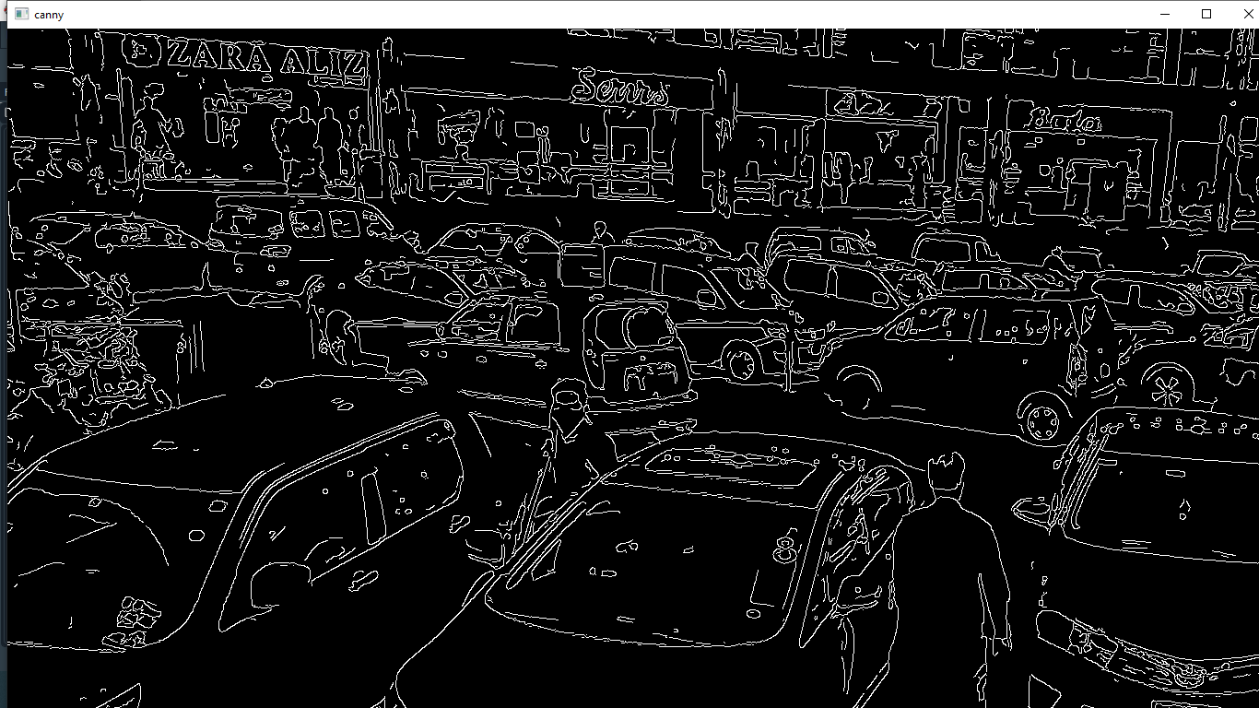

Figure 2.3: Canny function operation. [7]

### 2.1.3 Identifying empty/filled parking spaces

After the step of selecting and detecting ROIS from the video-stream, we can identify if a parking space is available or unavailable, using some libraries. I am using OpenCV library[8]. Some output examples are as follows. In Figure 2.5 and Figure 2.6, the parking spaces are identified with some spaces having cars parked (unavailable) as red boxes and some having no cars parked (available) as green boxes.

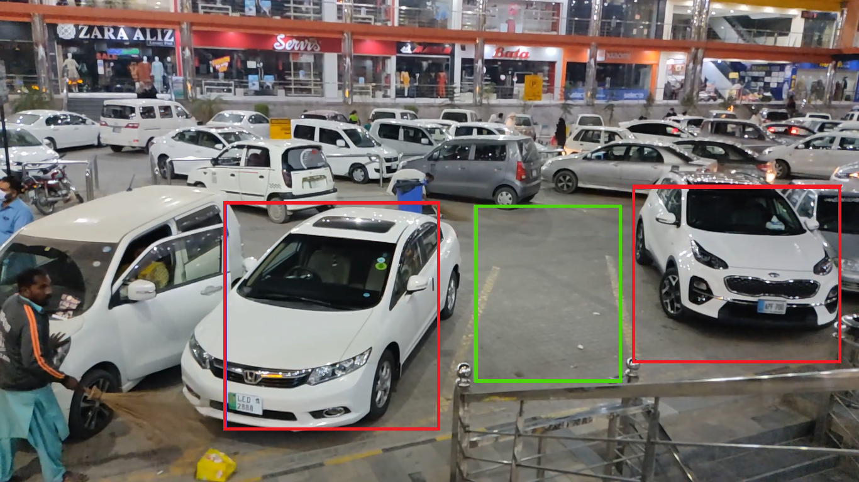

Figure 2.4. Detection and identification of available and unavailable parking spots.

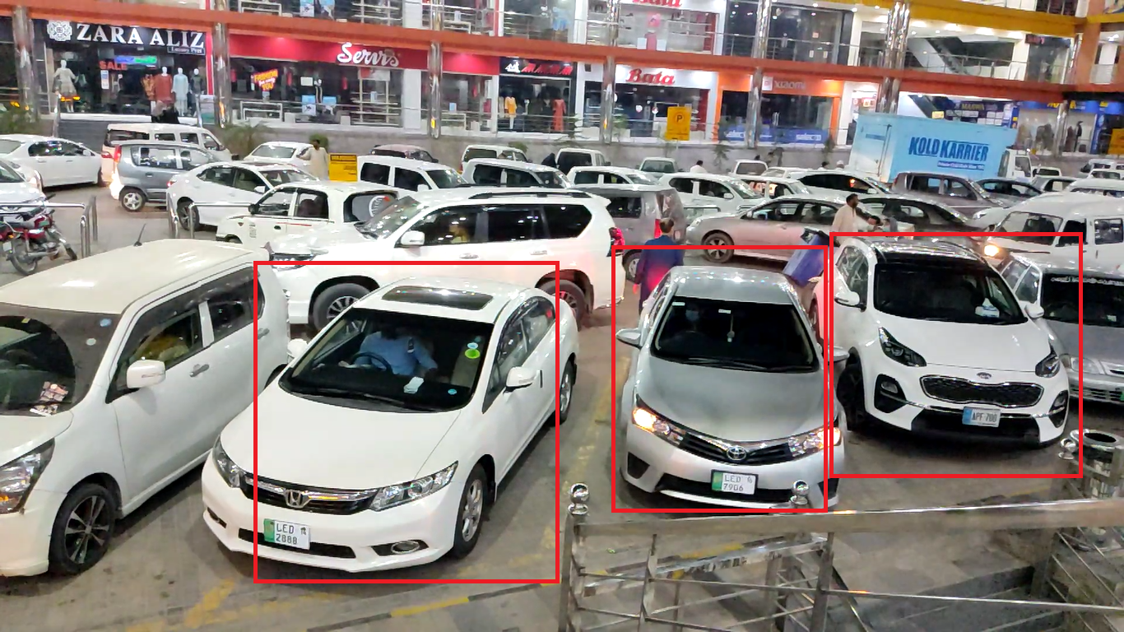

Figure 2.5. Detection and identification of available and unavailable parking spots.

## 2.2 Areas of Studies

We require studies of different subjects for the formation of our project. From Software Engineering that will help us build a mobile app at the end, telling us about the status the parking areas, Computer Science that will help us integrate and set up our hardware including our cameras and computer [8] [4], Artificial Intelligence which will help us apply different algorithms to detect our parking spaces. [2], Database which will help us to store data into the appropriate databases.

## 2.3 Reasons of Development

The main purpose for making the smart parking system is to aid the hectic task of finding free parking spaces when you are at a busy parking area [8]. It is sometimes very difficult to find parking at office timings and thus takes a lot of time [1]. Therefore, this causes time wastage and fatigue. Our system is a solution that specifically handles the parking areas, identifies free areas, locates free slots to the driver and stores the information of the parked cars in the database. Also, the mobile app lets you see the status of the parking lots while you are at your home or anywhere else. We see that it is burden for the parking guys to locate the free spaces manually and then navigate the drivers towards them. So, it will become easy for the drivers to park and for the parking guys to manage parking.

The purpose of development and implementation of this system is to make parking easy for the drivers as well as the management. Also, it is very difficult to track that which parking space is empty and where in our conventional parking systems, therefore it is a massive solution to address the problems mentioned above [1].

The related study section explains that there is no efficient smart parking system present yet in our country. Furthermore, this system shows a detailed archive to keep the record of the cars parked.

## 2.4 Proposed Methodology

Canny is a multi-stage algorithm and we will go through each stage:

### 2.4.1 Noise Reduction

Since edge detection is susceptible to noise in the image, first step is to remove the noise in the image with a 5x5 Gaussian filter.[9]

### 2.4.2 Finding Intensity Gradient of the Image

Smoothened image is then filtered with a Sobel kernel in both horizontal and vertical direction to get first derivative in horizontal direction (Gx) and vertical direction (Gy). From these two images, we can find edge gradient and direction for each pixel as follows:

$$Edge_{Detection\left(G\right)}=\sqrt{G_{x}^{2 }+G_{y}^{2 }}$$

$Angle(θ) = \tan^{-1}\left({G_{y}}/{G_{x}}\right)$

Gradient direction is always perpendicular to edges. It is rounded to one of four angles representing vertical, horizontal and two diagonal directions. [9]

### 2.4.3 Non-maximum Suppression

After getting gradient magnitude and direction, a full scan of image is done to remove any unwanted pixels which may not constitute the edge. For this, at every pixel, pixel is checked if it is a local maximum in its neighborhood in the direction of gradient. Check the Figure below:

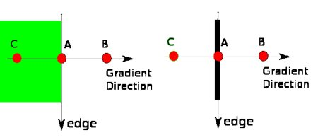

Figure 2.6. Canny function logic [6]

Point A is on the edge (in vertical direction). Gradient direction is normal to the edge. Point B and C are in gradient directions. So, point A is checked with point B and C to see if it forms a local maximum. If so, it is considered for next stage, otherwise, it is suppressed (put to zero). In short, the result you get is a binary image with "thin edges". [9]

### 2.4.4 Hysteresis Thresholding

This stage decides which of all edges are really edges and which are not. For this, we need two threshold values, minVal and maxVal. Any edges with intensity gradient more than maxVal are sure to be edges and those below minVal are sure to be non-edges, so discarded. Those who lie between these two thresholds are classified edges or non-edges based on their connectivity. If they are connected to "sure-edge" pixels, they are part of edges. Otherwise, they are also discarded. See the image below:

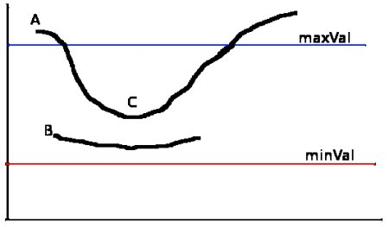

Figure 2.7. Canny function logic [6]

The edge A is above the maxVal, so considered as "sure-edge". Although edge C is below maxVal, it is connected to edge A, so that also considered as valid edge and we get that full curve. But edge B, although it is above minVal and is in same region as that of edge C, it is not connected to any "sure-edge", so that is discarded. So, it is very important that we must select minVal and maxVal accordingly to get the correct result. This stage also removes small pixels noises on the assumption that edges are long lines. [9] The Output will be as follows after applying canny function to a video source[10], [11]



Figure 2.8. Applying canny algorithm on Video Source Data [9]

## 2.5 Experiments

In this FYP Documentation, we present an effective and efficient approach using advanced computer vision techniques to improve parking lot detection accuracy. In this section, we’ll give experiment results to demonstrate our method.

In the first part, we select all the parking spots in a parking area, using the selectROIS() function. To do so, first we capture an image from the live video stream and on it define our regions of interest. Therefore, we get the coordinates of ROIS in the view. These ROIS are then used in next part.



Figure 2.9. ROIS Selected from Video-Source

In the second part, the selected ROIS are then detected for cars. If a car is parked, it is marked as unavailable, and a red rectangle appears on this parking slot. However, if the slot is free and no car is parked, a green rectangle appears on the spot. In this part, the Canny Edge Detection algorithm is used to detect the edges in each parking spot and then mark them as available or unavailable [12]. Then these results are sent to the real-time database from where they can be fetched by the user in the app and the admin who can see the analyses reports.



Figure 2.10. ROIS Detected as Available and Unavailable from Video-Source

The results of our Experiment show that our system successfully detects Available and Unavailable Parking Spots, and the data of the corresponding spots in sent to the database. Our Mobile App loads the data immediately at real-time and displays it to the user.

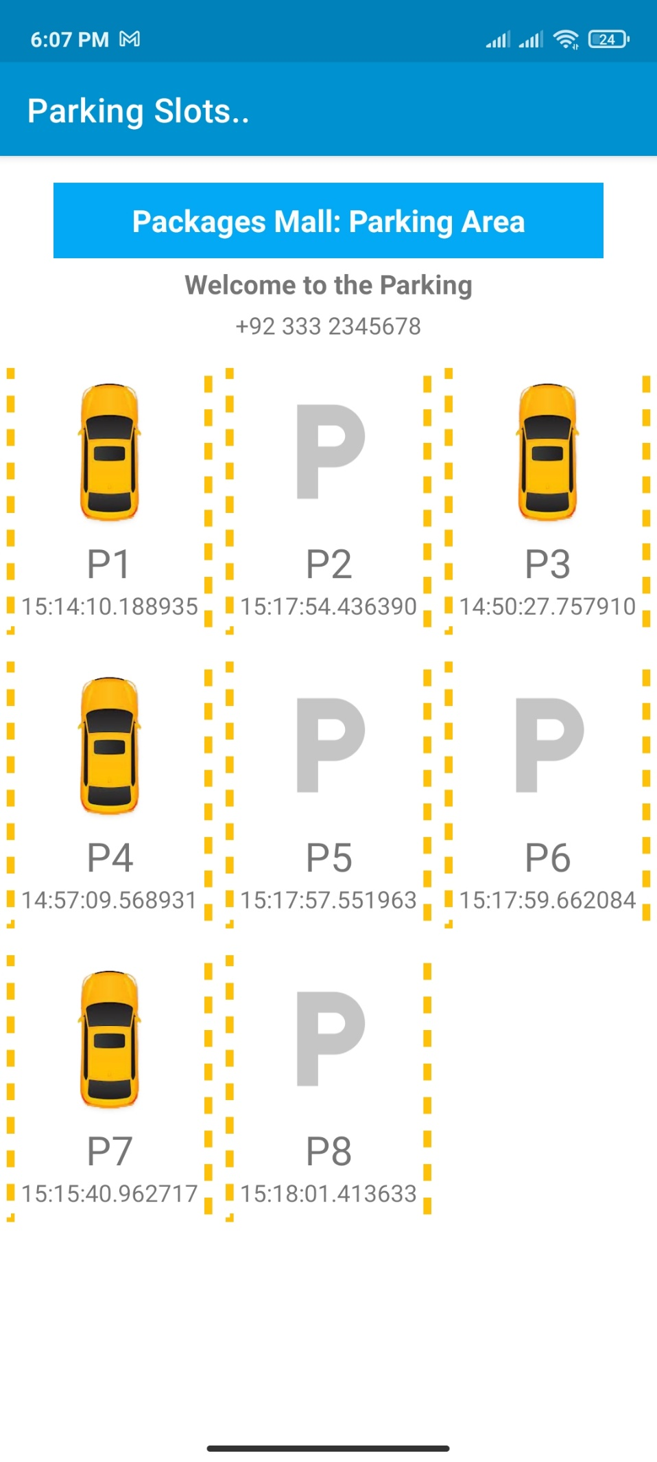

Figure 2.11. Parking Slots View in android application

## 2.6 Parking System

After successfully identifying available and unavailable parking spots, the data of these spots will be sent to the database and then fetched into our application for users to see the parking status of the malls.

In our parking database, we will send each parking spot data along with the entry time, exit time, date, and spot id, as shown in Table 2.1.

Table 2.1: Parking Records Shows

|  |  |  |  |  |
| --- | --- | --- | --- | --- |
| ID | **Status** | **Entry Time** | **Exit Time** | **Date** |
| 1 | Unavailable | 22:54:08.842814 | 22:55:04.442863 | 2021-08-23 |
| 2 | Unavailable | 22:54:11.257828 | 22:55:01.136263 | 2021-08-23 |
| 3 | Available | 22:59:48.510976 | 99.99.99 | 2021-08-23 |
| 4 | Unavailable | 22:58:52.938533 | 22:59:38.510976 | 2021-08-23 |

# **Chapter 3**

# **Problem Definition**

## 3.1 Problem Definition

The problem we are facing form our current system was basically not neglectable. In our country, there are large number of malls and big organizations that have assign a big area of their building to a parking-lots. In current system, we basically enter in the parking area and take a parking ticket. At that point, if there were peak hours of the mall you have entered in, then you must wait for you turn to park. After entering in the parking-area you must move around the parking area to find the place to park your car. So, to solve these problems we must develop an app that can solve all these problems of the current system.

There will be a great contribution to the commercial society of our country and for the common people out there which are basically facing the parking problem. If we are successful to build our project, then it will become an ease for the customer and if parking is managed, your business will grow rapidly too.

## 3.2 Existing Methodologies

There are many stages or methodology in software development that is called the software development life cycles (SDLC). Software Development is a process that contain different parts, tasks, procedure, phase etc. In last many years, we focused on developing the methodologies that can improve the quality and productivity of the developed software. We can also develop the software without adopting any methodology, that might be delivered easily and quickly, but productivity is affected.

With the usage of any development model, we can divide the development process into different phases, making prototyping, using part of code again in other places etc. Some existing methodologies in software development are as follows.

* Incremental Model
* Waterfall Model
* Spiral Model
* Prototype
* Iterative Model
* Agile

## 3.3 Adopted Methodologies

We will use the incremental prototype model for making the project successful and improve its working and development to its best.

### 3.3.1 Incremental Prototype

Prototype is a model in which partial working software/system is developed instead of developing the complete product. Prototype is developed using the required current requirements of the customers, which are known at that time of development starts. With this methodology, there is less chances of changing the requirements during or after the development process. The original development and coding start when the customer is satisfied with the working of the prototype. In incremental Prototyping, the final product is decimated into different small prototypes and developed individually. Eventually, the different prototypes are merged into a single product.



Fig. 3.1. Incremental Prototype Model

## 3.4 Reason for Adopting Methodologies

We choose the incremental type inside the prototype model to develop the system with good productivity. In our system, we may need the steps of changing the requirements and needs of the users. We may need different requirements as well as different structure of this proposed system that is usable and valuable for the organization. Moreover, it will help us to divide the project into components that can be develop incrementally and the customers can test the desired system using prototyping.

# **Chapter 4**

# **System Requirement**

## 4.1 Functional Requirements

All the fundamental activities, actions or requirements that are main actions of our project is describe in this section.

**4.1.1 Authentication:**

User will login to view parking available and book parking.

**4.1.2 Sign-Up:**

New user can sign-up and register.

**4.1.3 Guest Login:**

Unregistered users can login to see cities, malls, and parking status.

**4.1.4 Select City:**

User will be able to select a city where he wants to go.

**4.1.5 Select Mall:**

User will be able to select a mall where he wants to go.

**4.1.6 Check availability:**

User will be able to see the free slots of the selected mall.

**4.1.7 View Parked time:**

Admin can see the parked time of every car in the database.

**4.1.8 Slot Identification:**

The system will detect the slots through cameras and save the coordinates in a file.

**4.1.9 Car Detection:**

The system will detect the cars in the parking spaces through cameras and save information into the database.

**4.1.10 Entry/Exit Time:**

The system will detect the entry time when a car is parked and exit time when the car will leave the parking slot.

**4.1.11 Book a Spot:**

User will be able to book a parking spot before he goes.

**4.1.12 View Analysis:**

Admin will be able to view the analysis reports of cars parked today, this week and this month.

## 4.2 Requirement Table

Table. 4.1. Requirement Table

|  |  |
| --- | --- |
| Requirement Number (RQ #) | Details |
| RQ 1 | Authentication |
| RQ 2 | Sign-Up |
| RQ 3 | Guest Login |
| RQ 4 | Select City |
| RQ 5 | Select Mall |
| RQ 6 | Check Availability |
| RQ 7 | View Parked Time |
| RQ 8 | Slot Identification |
| RQ 9 | Car Detection |
| RQ 10 | Entry/Exit Time |
| RQ 11 | Book a Spot |
| RQ 12 | View Analysis |

There are some requirements of this system and their details that is show in Table 4.1.

## 4.3 Non-Functional Requirements

**4.3.1 Reliability:**

The system should be reliable. In case of system failure, the system should be able to recover quickly and continue working normally.

**4.3.2 Efficiency:**

The system should have fast response time. The app should not take much time to perform a task, like showing the free/filled parking slots.

**4.3.3 Confidentiality:**

The system should be secure. User should fill his/her email address and password to authorized to the system.

**4.3.4 Scalability:**

The system should be scalable. Even with an increasing number of users, system should be able to perform effectively.

**4.3.5 Usability:**

The system should be user friendly with ability to show users where they are in the system and guide them on some processes through programmed commands.

**4.3.6 Accessibility:**

The system is accessible to two entities only.

1. Admin with complete access
2. User with partial access.

**4.3.7 Availability:**

The application should be available 24/7.

**4.3.8 Maintainability:**

The ease with which we can maintain and fix all the errors and technical faults timely. The system should be easy to recover from failure and bugs can be resolved quickly and easily.

## 4.4 Functional Requirements Context

### 4.4.1 Context



Fig. 4.1. Smart Parking Process Flow

“Smart Parking Process Flow” visually that is detail is described in the Figure 4-1 above.

The process of the “Smart Parking System” can be described as below:

* **Register User:**

First, User must register itself to get access to app.

* **Select City:**

Then we must select city from the available cities, whose parking situation we want to see.

* **Select Mall:**

The user must select the mall and check the available parking slots in the mall.

* **Save details into the Database:**

All the details will be saved into the database like the parking slot id, slot status, entry and exit time of each parking record.

* **Maintain System:**

The system must be maintained as well as the databases must be stored with backups. Moreover, the Cameras must be maintaining and check regularly to be safe from technical faults.

### 4.4.2 Values

* **Parking slot ID:**

The Parking slot ID will be used to specify the parking slots in the area.

* **Slot Status:**

The Slot Status will be used to specify whether the slot is available or unavailable for a car to be parked.

* **Entry Time:**

The time when a car is parked in the slot is recorded and saved in database.

* **Exit Time:**

The time when a slot is emptied, and a car leaves the slot is noted and saved in database.

* **Date:**

The date when a slot is filled, and a car enters the slot is noted and saved in database.

### 4.4.3 Analysis

* **Categorization:**

The parking slots will be categorized according to their availability status. They will be either available or unavailable.

* **Save Parking Slots Records into Database:**

The slots records and statuses will be saved into the appropriate child nodes of the database.

### 4.4.4 Generate Report

The empty and filled parking-slots will be visible to the user. We can also make a report of all customers who have visited the mall that day, that week, that month and calculate the total revenue generated from that day, that week, and that month.

## 4.5 Class Diagram

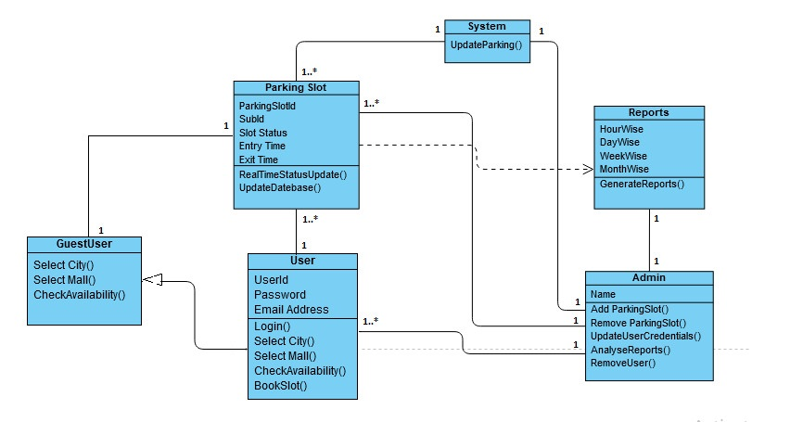

Figure 4.2 – Class Diagram of Smart Parking System

All the Entities with required field names and the functions that have the implementation of the functions are shown in Figure 4.2.

## 4.6 Use Case Diagram

### 4.6.1 Admin

Admin in basically maintaining the backend of the system, who has the authority to perform these activities with Parking Slots, User and report generation. Figure 4.3 show some functions that can be performed by admin like

* Add Parking Slots
* Remove Parking slots
* Send Reset password Emails
* Delete Users
* Generate analysis reports

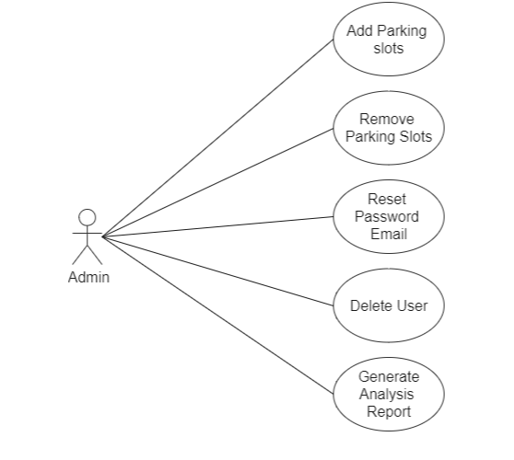

Figure 4.3 – Admin

### 4.6.2 User

User in the app is the person who use the application, who has the authority to perform these activities with mall, parking-slot. Figure 4.3 show some functions that can be performed by admin like view parking-slots, modify parking-slots.

* login
* View Parking slots, View Entry time, City, Mall
* Book Slot
* Select City, Select Mall

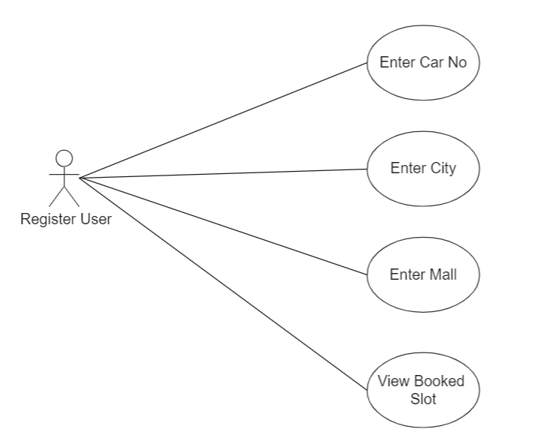

Figure 4.4 -Register User --->View Booked slot

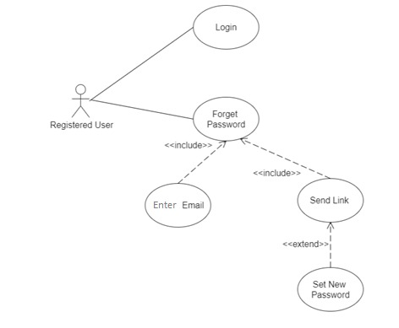

Figure 4.5 -Register User ---> Login

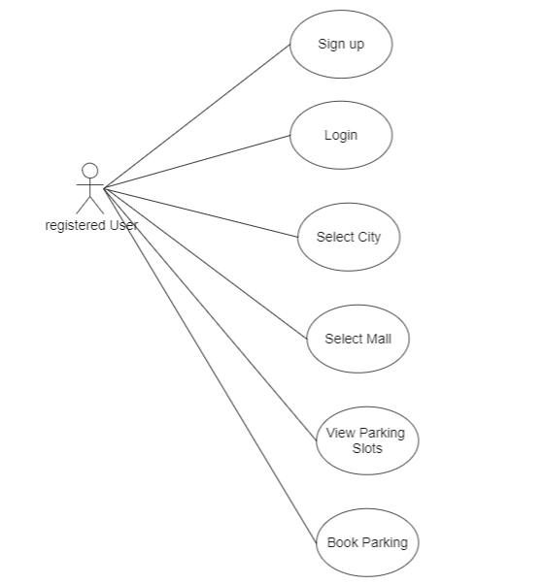

Figure 4.6 - Registered User 🡪 Book parking slot

### 4.6.3 Complete System

The complete Use-Case scenario of the system with all entities like admin, User, and Guest User are shown in Figure 4.7 as below.

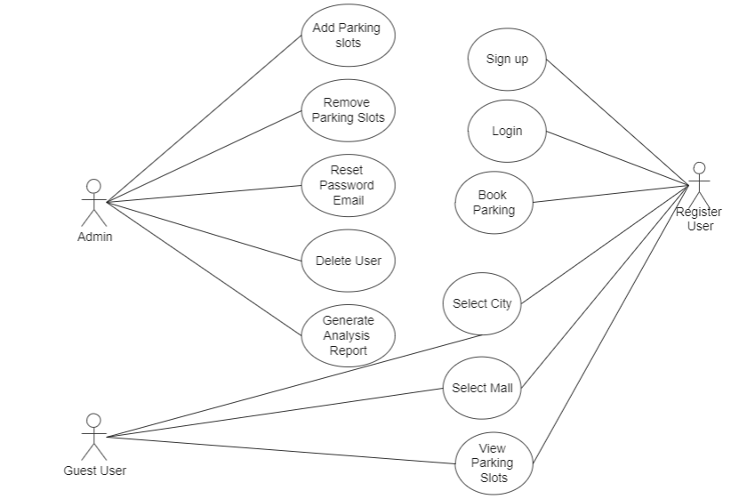

Figure 4.7 – Complete System Use Case Diagram

## 4.7 Data Flow Diagram

Figure 4.8 – Data Flow Diagram

Description the Data Flow of level 2-3 of all the entities of our system are shown in Figure 4.10 above.

# **Chapter 5**

# **Architecture Design**

## 5.1 Architecture

In all the projects architecture of the software defines the workflow and frameworks of the project model. The Architecture also helps the user or the programmers to study the model and easily use the system.

## 5.2 System Architecture

System Architecture shows the workflow of our Parking system that is how the admin can interact with the system and how the user can use the android application. User can simply use the application by entering login details, as this system is an android application.



Fig. 5.1. System Architecture [2]

## Sequence Diagram

### 5.3.1 User Sign-In Sequence Diagram

This describes the “User” sequence that is how user perform sign in. He/she enters the email and password, which then validates further and if match found then the event is successful Figure 5-2.



Fig. 5.2. User Sign-In Sequence Diagram

### 5.3.2 Forgot Password by User Sequence Diagram

This shows the how the User updates his password. User will enter the email against which password needs to be reset. An email will be sent to user for reset password. In email, user will enter new password that will be saved in the database. Figure 5-3.



Fig. 5.3. Forgot Password by User Sequence Diagram

### 5.3.3 Register User Sequence Diagram

This shows the how the user creates a new account. User will enter the details of user like email and password that will validate the user on login in Figure 5-4 below.



Fig. 5.4. Register User Sequence Diagram

### 5.3.4 Guest Login Sequence Diagram

This shows the how the User can login without creating an account. User will click the guest login button and then enter the app without the need to have an account in Figure 5.5 below.



Fig. 5.5. Guest Login Sequence Diagram

### 5.3.5 View Cities by User Sequence Diagram

This shows the how the User view all the city records using the system. User just clicks the view parking slots button and that will fetch records of all the cities and show it on the GUI in Figure 5-6.



Fig. 5.6. View Cities by User Sequence Diagram

### 5.3.6 View Mall by User Sequence Diagram

This shows that how the user views the malls present for a city in database. All the malls present in the database for a respective city are fetched and displayed in Figure 5-7 below.



Fig. 5.7. View Mall by User Sequence Diagram

### 5.3.7 View Parking Slots by User Sequence Diagram

This shows the how the User can see the details of the parking slots in the application. User after entering the city name and mall name can see the status of all the present parking slots. The status and the number of the parking slots will be displayed to the user in Figure 5-8 as below.



Fig. 5.8. View Parking Slots by User Sequence Diagram

### 5.3.8 Book Parking by User Sequence Diagram

This shows the how the User books a parking spot through the application. If empty slots are available in the database, the user can book it by entering the vehicle number. If no parking slots are available, the user gets message of no available slots and cannot book a slot Figure 5-9 below.



Fig. 5.9. Book Parking by User Sequence Diagram

### 5.3.9 Generate Analytics Report by Admin Sequence Diagram

This shows the how the admin generates the analytics report of the parking records in the database. Admin just must run the analytics code and be able to see the daily, weekly, and monthly analytics reports after the system fetched the data from the database Figure 5-10 below.



Fig. 5.10. Generate Analytics Report by Admin Sequence Diagram

## 5.4 Activity Diagram

### 5.4.1 Register_User log-In Activity Diagram

This figure describes the “Register_User” Activity Flow that is how admin perform sign in. He/she enters the Email and password, which then validates further and if match found then the Admin Page Loads, in Figure 5-11 below.

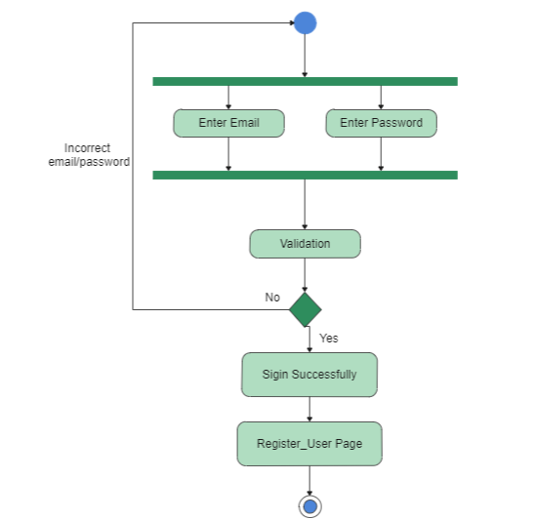

Fig. 5.11 Register_User Sign-In Activity Diagram

### 5.4.2 Reset Password by Register_User Activity Diagram

This shows the how the Register_User Reset his password. Register_User will enter the email address and click the ‘send reset link’. The email for resetting the password will send to your email. Click the link in the email ans the new window open. Enter the new password and update. The new password will update in the database.

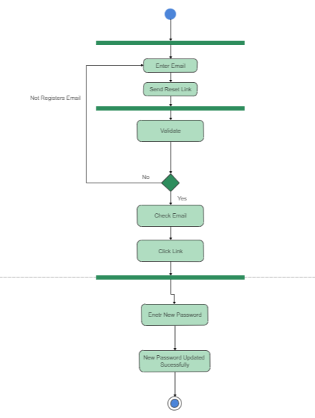

Fig. 5.12 Register_User Forget Password Activity Diagram

### 5.4.3 View Parking Slots by Guest_User Activity Diagram

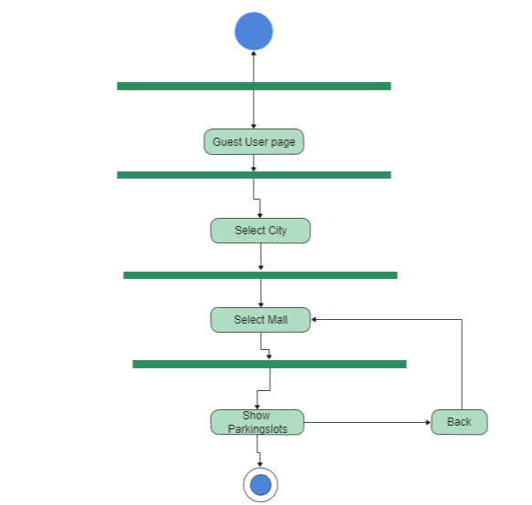This shows the how the Guest_User view the all the Parking Slots using the App. First, the Guest User have to Enter the app and then just have to click the city, then Mall and the app fetch all the data related to the parking slots of the specific Mart and display that data onto the GUI of the app.

Fig. 5.13 Guest_User View Parking Slots Activity Diagram

### 5.4.4 View Parking Slots by Register_User Activity Diagram

This shows the how the Register_User view the all the Parking Slots using the App. First, the Guest User have to Enter the app and then just have to click the city, then Mall and the app fetch all the data related to the parking slots of the specific Mart and display that data onto the GUI of the app.

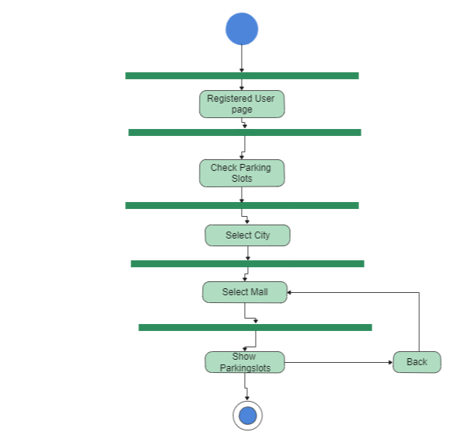

Fig. 5.14 Register_User View Parking Slots Activity Diagram

### 5.4.4 Book Parking Slots by Register_User Activity Diagram

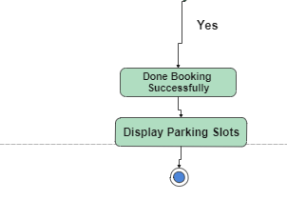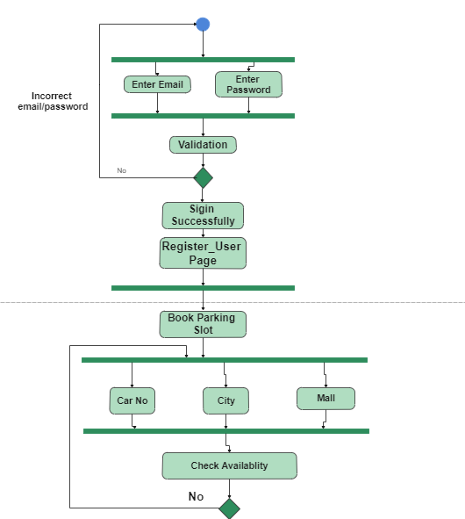This shows that how the Register_User book the Parking Slots using the App. First, the Register_User login to the app and then click on Book Parking Slot and then enter Car No, City, Mall and press Book and display the GUI of the parking slots which the book car icon on the display. The app fetch all the data related to the parking slots of the specific Mart and display that data onto the GUI of the app.

Fig. 5.15 Register_User Book Parking Slots Activity Diagram

### 5.4.5 Select Parking Slots by Admin Activity Diagram

This shows that how the Admin can select/identify there parking slots vey first time when the system is implemented to the specific mall parking area. The Admin can run the system file name as “SpotSelector’ that display the screen and at that the admin draw the rectangle to identify the parking slot areas. After selecting each slot the user press enter to save that as the each slot in the database.

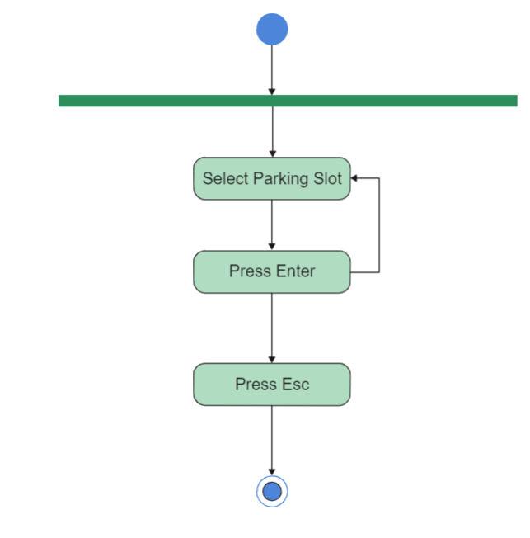

Fig. 5.16 Admin Select Parking Slots Activity Diagram

### 5.4.5 Delete User by Admin Activity Diagram

This can show how the admin delete the user manually from the database. This will how the user delete user from the database by searching that from their email address. Below diagrams show the database activities

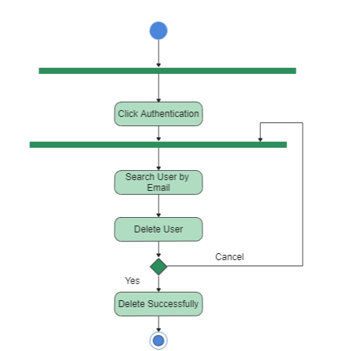

Fig. 5.17 Admin Delete User Activity Diagram

### 5.4.6 Generate Analysis Report by Admin Activity Diagram

This can show how the admin can generate reports of each date vise, hour vise, Month vise.

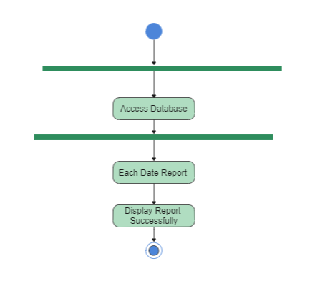

Fig. 5.18 Admin Generate Date Vise Report Activity Diagram

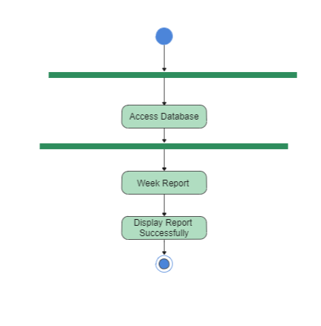

Fig. 5.19 Admin Generate Week Vise Report Activity Diagram

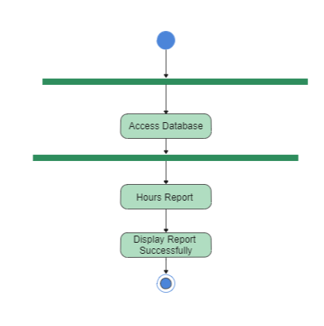

Fig. 5.20 Admin Generate Hour Vise Report Activity Diagram

## 5.5 Data Flow Diagram

Data Flow Diagram is at number 5th of Software Engineering paradigm. It is one of the most important diagrams, which tells the flow of data in the system. That how the data flows from entity to processes and from processes to the database. It also shows how the information flows input or output and tells how the data is stored in the different databases of the system. There are mostly three levels of Data Flow Diagram starting from 0-Level to proceeding levels

### 5.5.1 0-Level Data Flow Diagram

0-Level DFD Diagram is most simple and basic DFD that shows how the stakeholders i.e., Users and Admin or any actor interact with the system as shown in Figure 5-21



Fig. 5.21. 0-Level Data Flow Diagram

### 5.5.2 1-Level Data Flow Diagram

1-level DFD just add little detail to 0-level DFD that is entities can direct interact with process but cannot directly interact with data stores as shown in Figure 5-22.



Fig. 5.22. 1-Level Data Flow Diagram

### 5.5.3 2-3-Level Data Flow Diagram

Further Details add to 1-Level Data Flow Diagram that is it shows the other functionality to the system as shown in Figure 5-23.



Fig. 5.23. 2-3-Level Data Flow Diagram

# **Chapter 6**

# **Testing**

## 6.1 Test Cases

Test cases are developed for testing the functionality of your system. Test cases are developed for different features and the output determines whether the system is performing right under specific conditions or not.

## 6.2 Black Box Testing

A type of testing in which tester does not know about the structure of the system, its design, its code. System tested by providing different inputs and results of these inputs are matched with supposed outcomes.

### 6.2.1 Sign-In Test Case

Login can be performed by users. Therefore, figure 6-1 shows the GUI, in which the user will enter the email and password to login. We will see some test cases of the current case in Table 6-1.

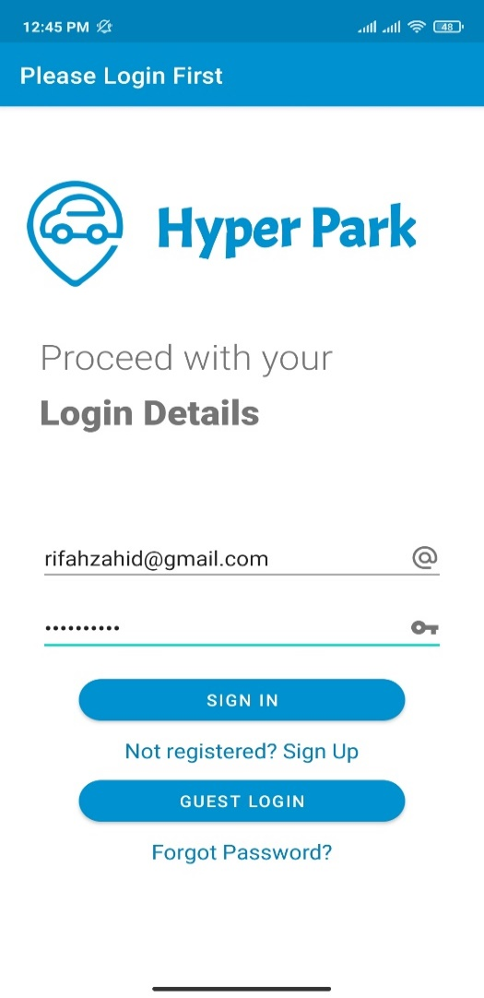

Fig. 6.1. Sign-In Test Case

Table. 6.1. Sign-In Test Case Table

|  |  |  |  |  |  |
| --- | --- | --- | --- | --- | --- |
| **Test Case** | **Test Scenario** | **Test Steps** | **Test Data** | **Result** | **Pass/Fail** |
| 1 | Enter invalid Email | Enter Email,  Password | Email= rifah@gmail.com  Password= 1234567890 | Error: incorrect credentials | Pass |
| 2 | Enter valid Email and password | Enter Email, Password | Email= rifahzahid@gmail.com  Password= 1234567890 | Login successful | Pass |
| 3 | Enter invalid password | Enter  Email, Password | Email= rifahzahid@gmail.com  Password= abc123 | Error: incorrect credentials | Pass |

### 6.2.2 Sign-Up Test Case

Sign-Up is to be performed by the users. Therefore, figure 6-2 shows the GUI, in which the user will enter the email and the password. We will see some test cases of the current case in Table 6-2.

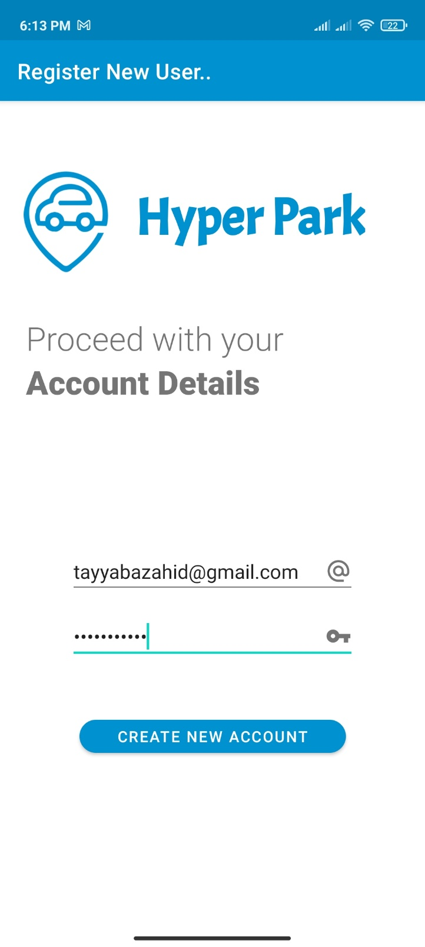

Fig. 6.2. Sign-Up Test Case

Table. 6.2. Sign-Up Test Case

|  |  |  |  |  |  |
| --- | --- | --- | --- | --- | --- |
| **Test Case** | **Test Scenario** | **Test Steps** | **Test Data** | **Result** | **Pass/Fail** |
| 1 | Enter no Email and no Password | Enter no inputs | Email=  Password= | Please Enter All Credentials | Pass |
| 2 | Enter Email but no Password | Enter Email | [Email=tayyabazahid@gmail.com](mailto:Email=tayyabazahid@gmail.com)  Password= | Please Enter All Credentials | Pass |
| 3 | Enter no Email but enter Password | Enter Password | Email=  Password=1234567890 | Please Enter All Credentials | Pass |
| 4 | Enter Email and Password both | Enter Email, Password | [Email=tayyabazahid@gmail.com](mailto:Email=tayyabazahid@gmail.com)  Password=1234567890 | Login Successful | Pass |

### 6.2.3 Forgot Password Test Case

Forgot Password is only performed by only users. Therefore, figure 6-3 shows the GUI, in which the user will enter the email address to send a reset password email. We will see some test cases of the current case in Table 6-3.

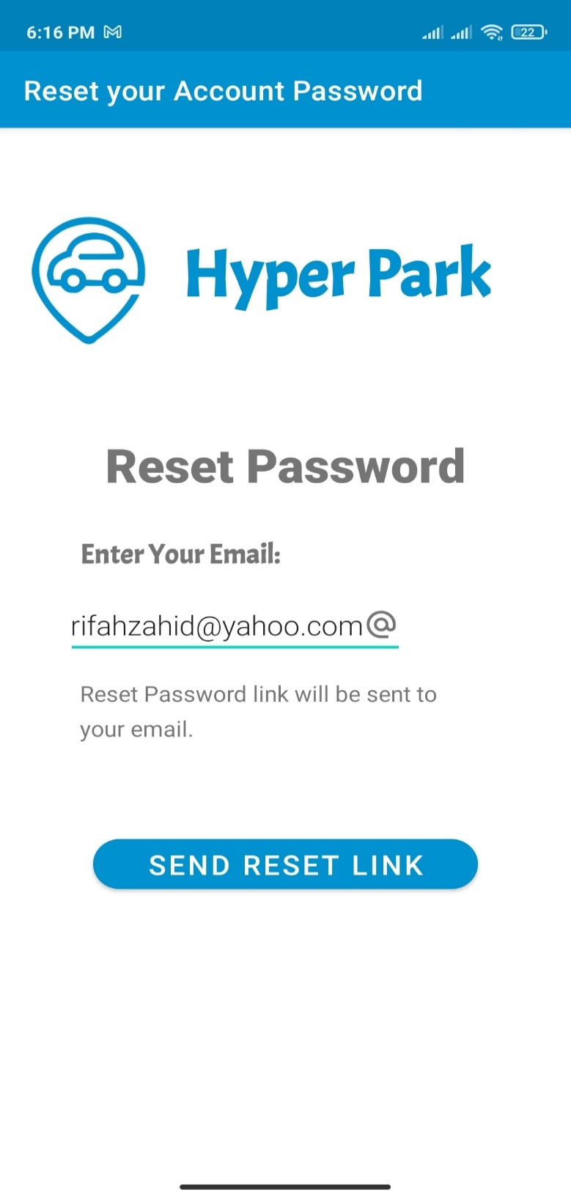

Fig. 6.3. Forgot Password Test Case

Table. 6.3. Forgot Password Test Case

|  |  |  |  |  |  |
| --- | --- | --- | --- | --- | --- |
| **Test Case** | **Test Scenario** | **Test Steps** | **Test Data** | **Result** | **Pass/Fail** |
| 1 | Enter no Email | Do not enter Email | Email= | Error: Email address is not provided | Pass |
| 2 | Enter Email | Enter Email | Email=rifahzahid@yahoo.com | Reset Password Link is sent | Pass |

### 6.2.4 Book a Spot Test Case

Book a spot is perform by only the registered users. Therefore, figure 6-4 shows the GUI, in which the user will enter the Vehicle Registration number, the City Name, The Mall Name to validate if the record is present or not and thus a Parking Spot will be booked in specified city and specified mall. We will see some test cases of the current case in Table 6-4.

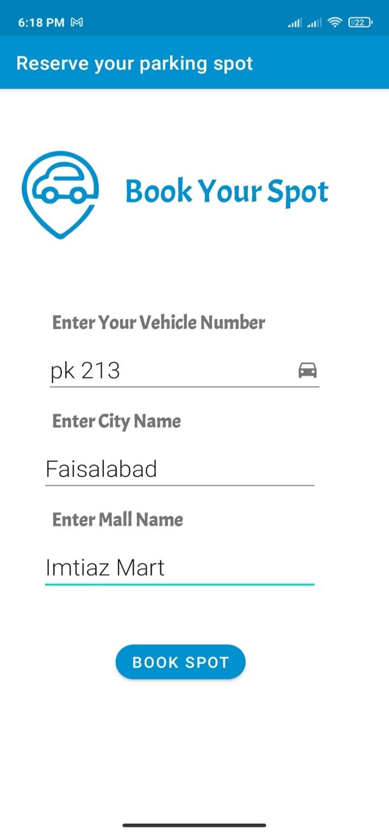

Fig. 6.4. Book a Spot Test Case

Table. 6.4. Book a Spot Test Case

|  |  |  |  |  |  |
| --- | --- | --- | --- | --- | --- |
| **Test Case** | **Test Scenario** | **Test Steps** | **Test Data** | **Result** | **Pass/Fail** |
| 1 | Enter No Vehicle Number, no City Name, and no Mall Name | Do not enter Vehicle Number, City Name and Mall Name | Vehicle Number=  City Name=  Mall Name= | Error: Enter Data in all fields | Pass |
| 2 | Enter Vehicle Number and, valid City Name and Mall Name | Enter Vehicle number, invalid City Name, and valid Mall Name | Vehicle Number= pk 213  City Name=Multan  Mall Name=Mall of Islamabad | Error: City not registered | Pass |
| 3 | Enter Vehicle Number and, valid City Name and Mall Name | Enter Vehicle number, valid City Name, and invalid Mall Name | Vehicle Number= pk 213  City Name=Lahore  Mall Name=Mall of Multan | Error: Mall not registered | Pass |
| 4 | Enter Vehicle Number, Valid City Name and Valid Mall Name | Enter Vehicle Number, valid City Name, and valid Mall Name | Vehicle Number= pk 213  City Name=Lahore  Mall Name=Emporium | Booking Successful | Pass |

# **Chapter 7**

# **User Manual**

## 7.1 Interface

Interfaces are the best visual representation that user can easily understand how to use the system. The following section elaborates all the interface of our system.

### 7.1.1 Sign-In Interface

Sign In interface for the users. Interface shown in Figure 7-1.

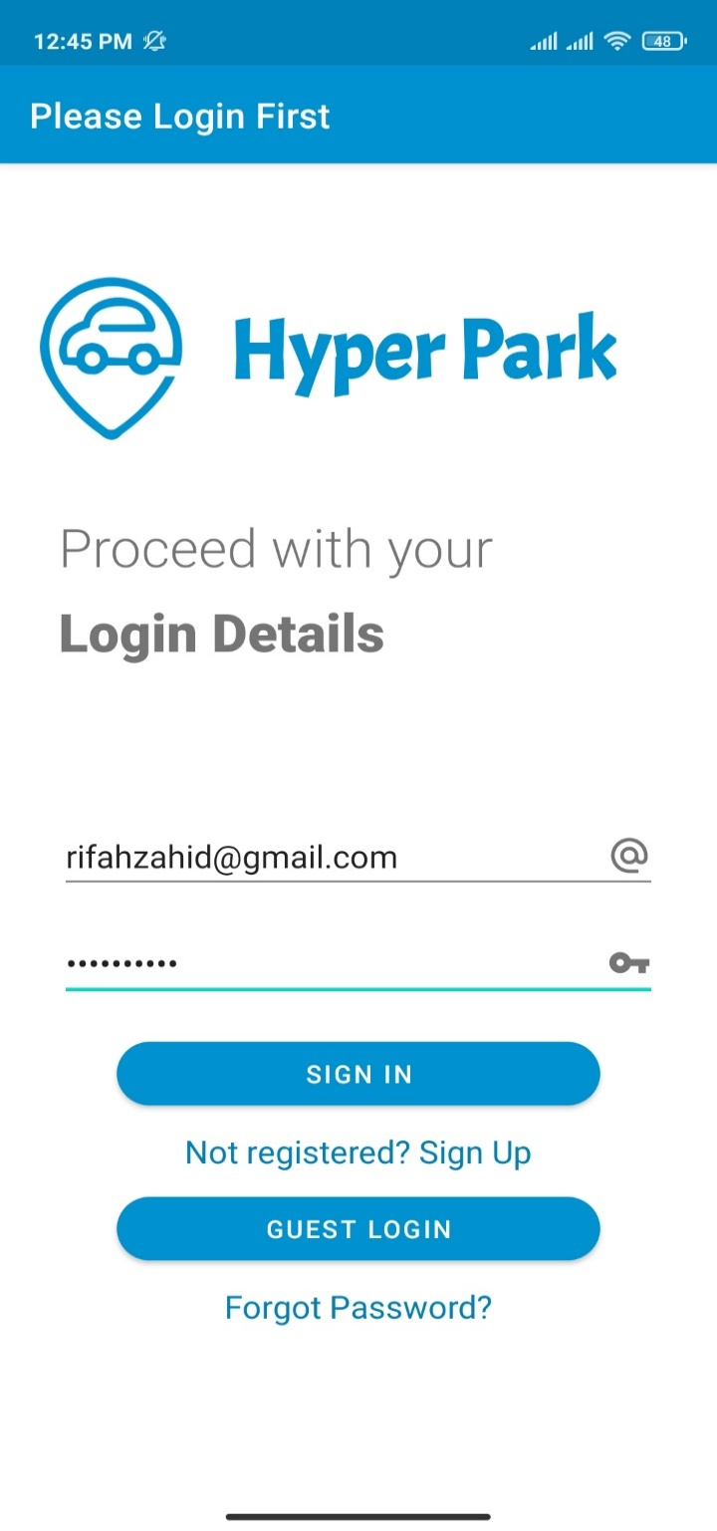

Fig. 7.1. Sign-In Interface

### 7.1.2 Sign-Up Interface

Sign up interface for the users. Interface shown in Figure 7-2.

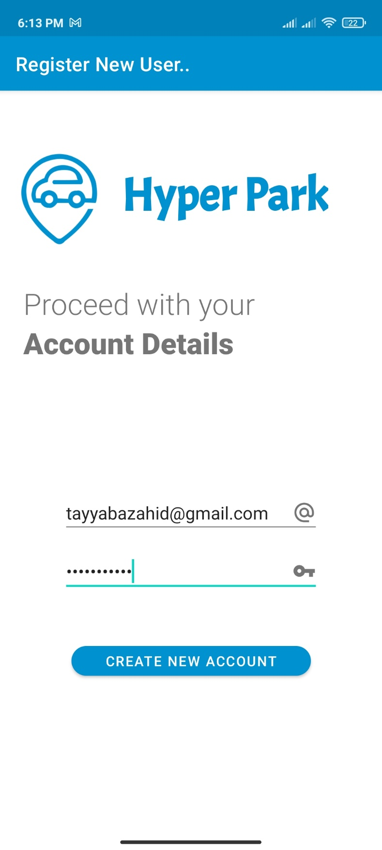

Fig. 7.2. Sign-Up Interface

### 7.1.3 Forgot Password Interface

Forgot Password interface for both the users. Interface shown in Figure 7-3.

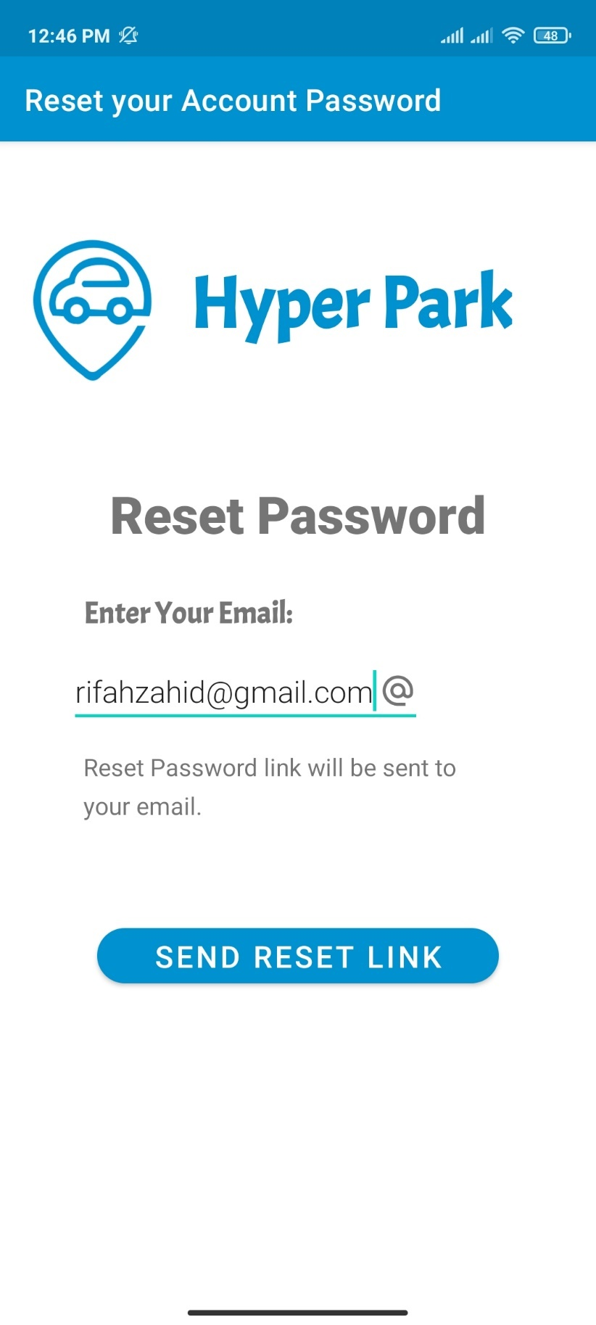

Fig. 7.3. Forgot Password Interface

### 7.1.4 Home for Registered User Interface

Home interface for the registered users. Interface shown in Figure 7-4.

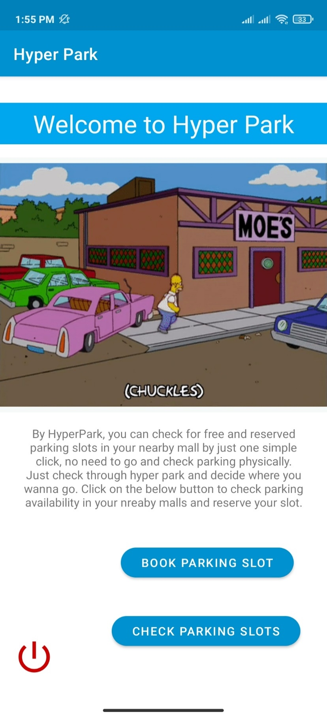

Fig. 7.4. Home for Registered User Interface

### 7.1.5 Home for Guest User Interface

Home interface for the guest users. Interface shown in Figure 7-5.

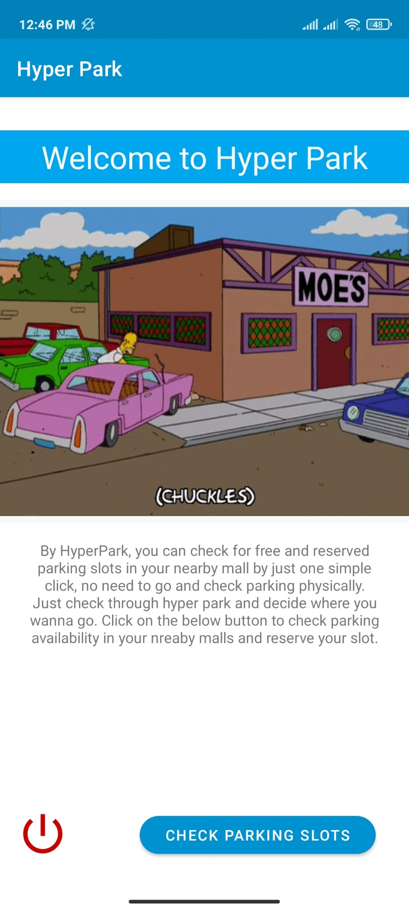

Fig. 7.5. Home for Guest User Interface

### 7.1.6 Select City Interface

Select City interface for the users. Users can only select the city, where the desired mall is located. Interface shown in Figure 7-6.

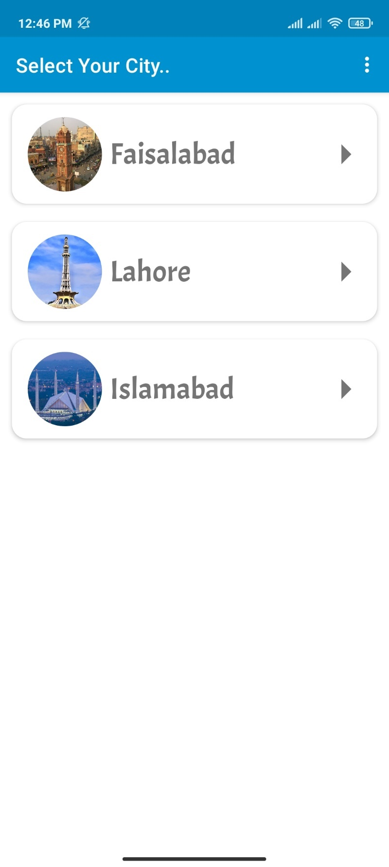

Fig. 7.6. Select City Interface

### 7.1.7 Select Mall Interface

Select Mall interface for the users. Users can only select the mall whose parking details they want to see. Interface shown in Figure 7-7.

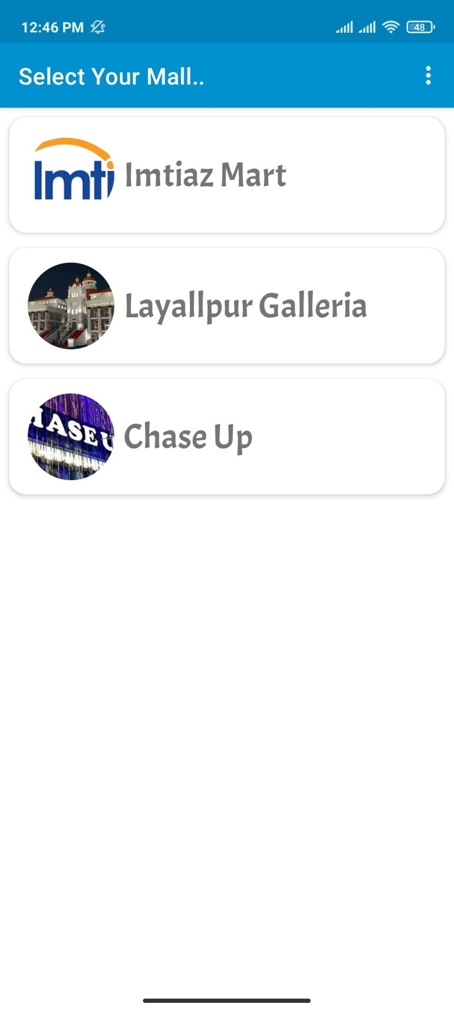

Fig. 7.7. Select Mall Interface

### 7.1.8 Parking Slots Interface

View Parking slots available and unavailable for the mall selected. Users can see on which spot the car is parked and which is free. Interface shown in Figure 7-8.

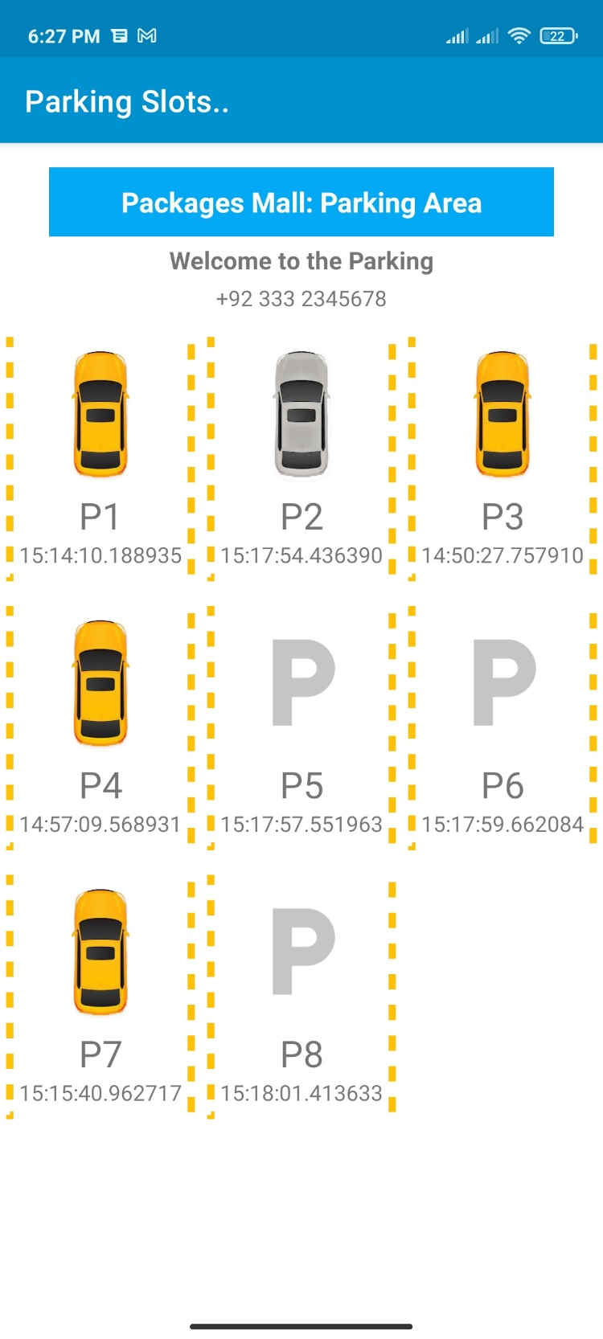

Fig. 7.8. Parking Slots Interface

### 7.1.9 Contact Developer Interface

View Contact Developer interface for users. Interface shown in Figure 7-9.

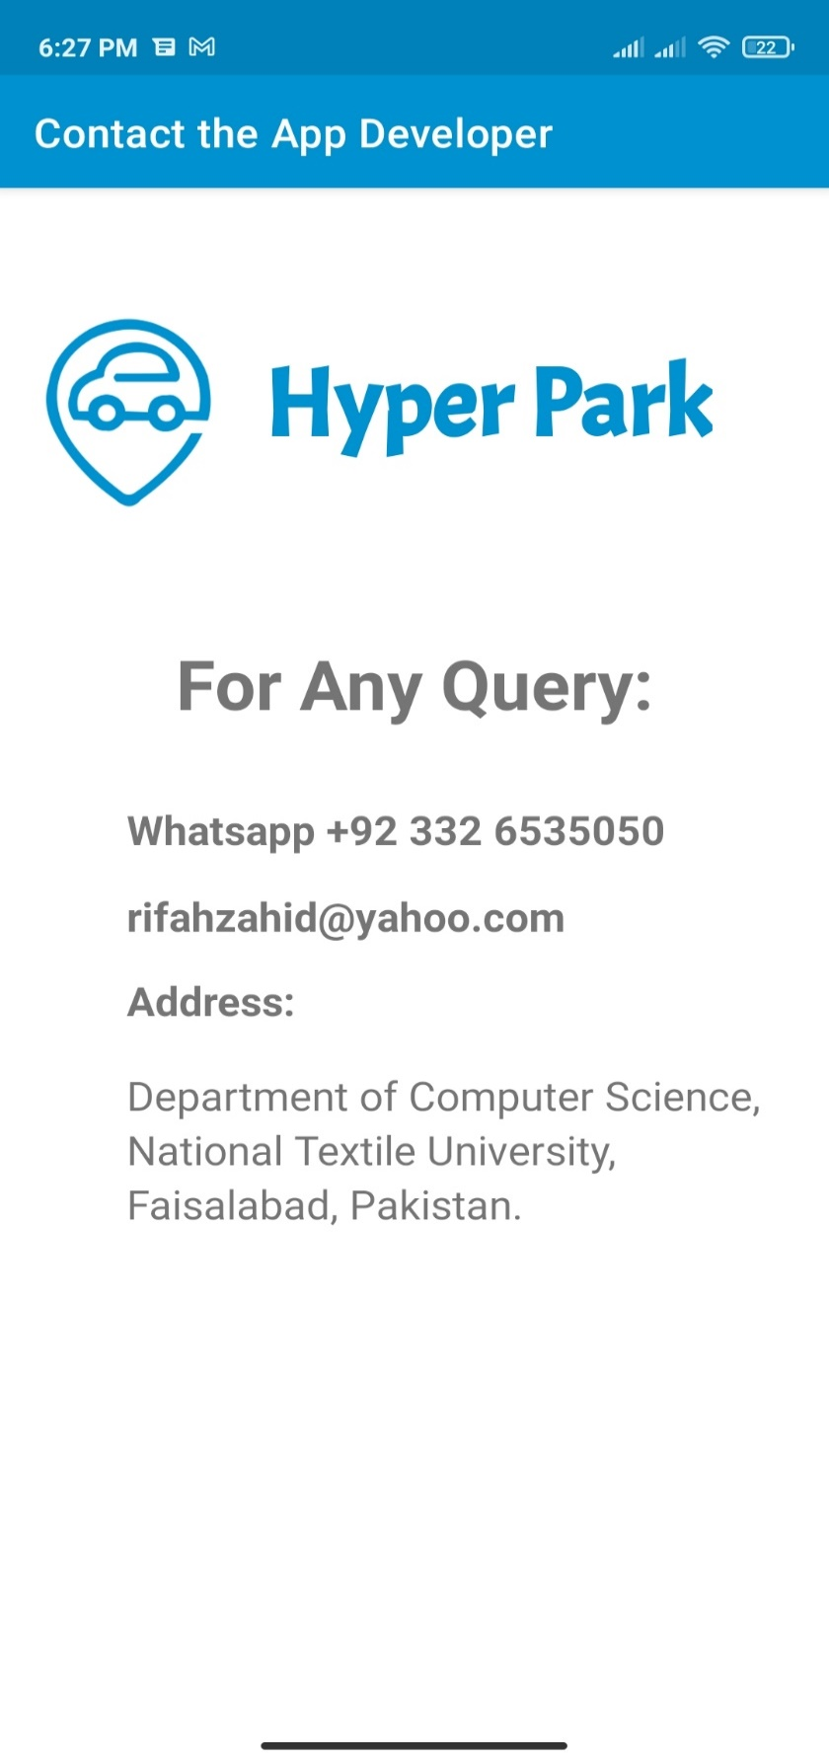

Fig. 7.9. Contact Developer Interface

### 7.1.10 Reserve Your Parking Spot Interface

Reserve Your Parking Spot interface for the users. Users can reserve or book a parking slot before they go to the mall so that they find the reserved slot free for them when they go. Interface shown in Figure 7-10.

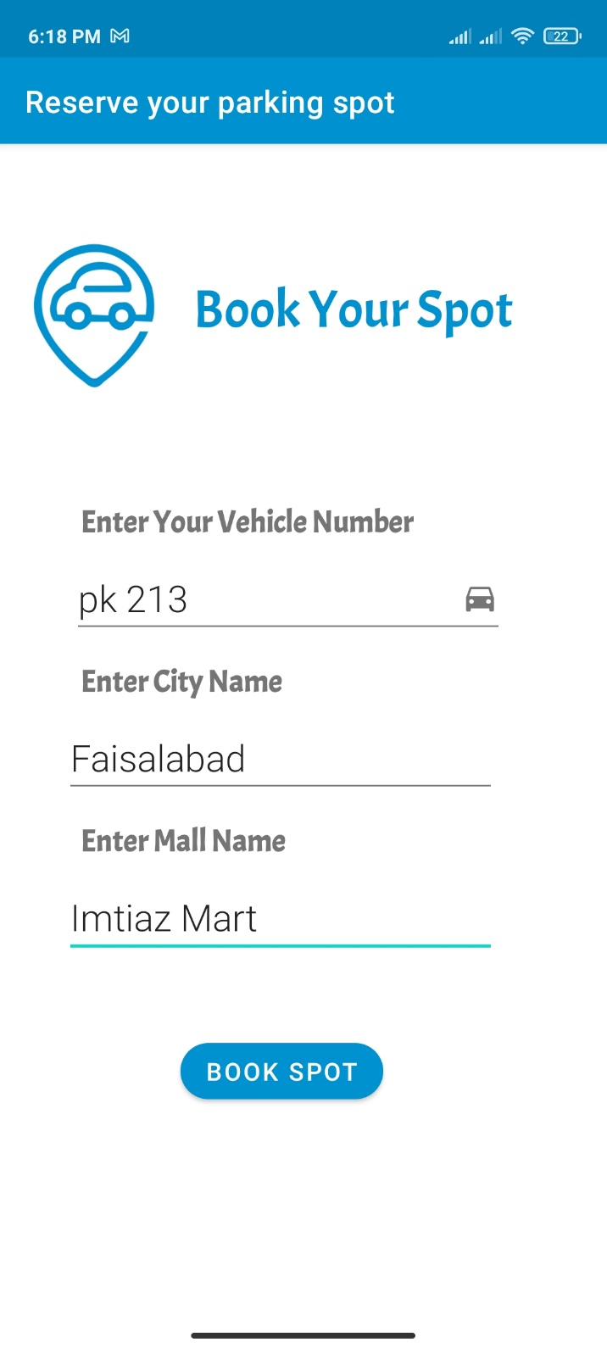

Fig. 7.10. Reserve Your Parking Spot Interface

## 8 Summary

In conclusion, in our research, after getting the live video stream data from the parking, we applied functions live selectROIS of OpenCV and Canny Edge Detection operator of OpenCV. OpenCV module was used because it is a very well trained and efficient python module to solve computer vision problems. Upon the number of edge pixels in each Roi, the spot is referred as available or unavailable.

In manual parking system, there are many issues like; time is wasted of the people when they go to a mall and do not find parking and thus, they must come back, and the time drivers waste in finding a free spot when at the parking, etc. Our proposed system is available to encounter all the problems discussed above. In addition, our proposed will be able to automatically detect free parking spots and update the data into an android application that tells users the status of the parking areas, even when away. In addition, our system updates the parking status to the app within seconds and thus, the data in the app is real-time and consistent. Moreover, the application lets us book parking spots in advance too.

# 9 Reference

[1] A. HAMZAH E, “DESIGN AND IMPLEMENT WSN/IOT SMART PARKING MANAGEMENT SYSTEM USING MICROCONTROLLER ABDULWAHHAB ESSA HAMZAH A project thesis submitted in fulfillment of the requirement for the award of the Degree of Master of Electrical: Communication Engineering FACULTY ,” no. June, pp. 1–28, 2018.

[2] M. S. Mufaqih, E. R. Kaburuan, and G. Wang, “Applying smart parking system with internet of things (IoT) design,” *IOP Conf. Ser. Mater. Sci. Eng.*, vol. 725, no. 1, 2020, doi: 10.1088/1757-899X/725/1/012095.

[3] F. Shaikh, B. S. Nikhilkumar, O. Kulkarni, P. Jadhav, and S. Bandarkar, “A Survey on ‘ Smart Parking ’ System,” *J. Clean. Prod.*, vol. 11, no. 2, pp. 9933–9939, 2015, doi: 10.15680/IJIRSET.2015.0410086.

[4] M. Fraifer and M. Fernström, “Investigation of smart parking systems and their technologies,” *Thirty Seventh Int. Conf. Inf. Syst. IoT Smart City Challenges Appl. (ISCA 2016)*, pp. 1–14, 2016.

[5] C. S. Tutika, C. Vallapaneni, and K. B, “Image Handling and Processing for Efficient Parking Space Detection and Navigation Aid,” 2018, [Online]. Available: http://arxiv.org/abs/1807.02424.

[6] P. Doll, R. Girshick, and F. Ai, “Mask R-CNN ar.”

[7] X. Ding and R. Yang, “Vehicle and Parking Space Detection Based on Improved YOLO Network Model,” *J. Phys. Conf. Ser.*, vol. 1325, no. 1, 2019, doi: 10.1088/1742-6596/1325/1/012084.

[8] J. Malhotra and H. Kaur, “A Review of Smart Parking System based on Internet of Things,” *Int. J. Intell. Syst. Appl. Eng.*, vol. 6, no. 4, pp. 248–250, 2018, doi: 10.18201/ijisae.2018448450.

[9] D. Acharya, W. Yan, and K. Khoshelham, “Real-time image-based parking occupancy detection using deep learning,” *CEUR Workshop Proc.*, vol. 2087, pp. 33–40, 2018.

[10] M. Heikkilä and M. Pietikäinen, “A texture-based method for modeling the background and detecting moving objects,” *IEEE Trans. Pattern Anal. Mach. Intell.*, vol. 28, no. 4, pp. 657–662, Apr. 2006, doi: 10.1109/TPAMI.2006.68.

[11] T. Ojala, M. Pietikäinen, and T. Mäenpää, “Multiresolution gray-scale and rotation invariant texture classification with local binary patterns,” *IEEE Trans. Pattern Anal. Mach. Intell.*, vol. 24, no. 7, pp. 971–987, Jul. 2002, doi: 10.1109/TPAMI.2002.1017623.

[12] C. Xu and X. Hu, “Real Time Detection Algorithm of Parking Slot Based on Deep Learning and Fisheye Image,” *J. Phys. Conf. Ser.*, vol. 1518, no. 1, 2020, doi: 10.1088/1742-6596/1518/1/012037.

